CSCI Databases
Pet Shop

Oscar Torres, Lazaro Vallejo
oscar.torres01@utrgv.edu
lazaro.vallejo01@utrgv.edu

- Introduction
Problem Description:
The purpose of the Moreno’s Pet Shop site was to make a user-friendly website to facilitate the purchase of animals, feed, and any other items a buyer would need to maintain their newly purchased animal or owned animals. This document runs through all of the requirements that an admin must navigate through to manage the website, as well as consumer interactions with the site to make an account and proceed to a purchase.
Background:
Moreno’s Feed and Pet Store first opened its doors in Donna Texas in June of 1979 by Gus Moreno Jr. After serving his country for 11 years in the United States Air Force, Gus returned to his roots in the Rio Grande Valley. Gus was raised on a farm and knew that he wanted to open a business related to agriculture and farm animals. Gus along with his wife Pat and six children were dedicated and determined to build a successful feed and pet business that could provide the Mid Valley communities with good products at reasonable prices and that were backed with great service.
In 1982, a second location was opened in Weslaco Texas which is now owned and operated by son, Leroy Moreno. Thanks to a very good customer base in Weslaco and surrounding communities, the Weslaco store blossomed. In order to provide a bigger and better selection of pet supplies and premium dog foods, Leroy Moreno built a new and larger building in 2004. The new store is located at 2424 East Business 83 which is right in front of Weslaco East High School. The Weslaco location is a full line pet shop where you can find all types of pets from birds like parakeets and cockatiels to small animals like hamsters and bunnies. The Weslaco store is well known for its selection of Valley grown puppies. It is also one of the few stores left in the Valley that sells baby chicks.
Overview:
The initial idea for the new Moreno’s Pet and Feed Shop site was to make a basic website that would display all readily available stock for the Moreno’s Pet and Feed Shop that is located in Weslaco, Texas. After several iterations of the project, the team came to the decision to add several other functions to the website while maintaining the Moreno’s Pet and Feed Shop feel that was already present in the currently live website for the shop. This document will go over the various improvements that the team has made over the current website, as well as display how much of a difference a new coat of paint can do for an already existing business.

- Database Design
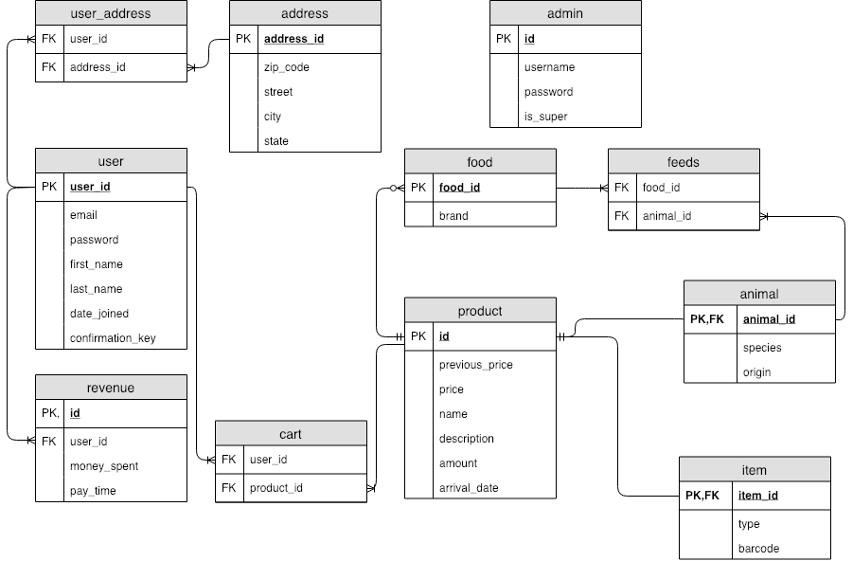

ER Diagram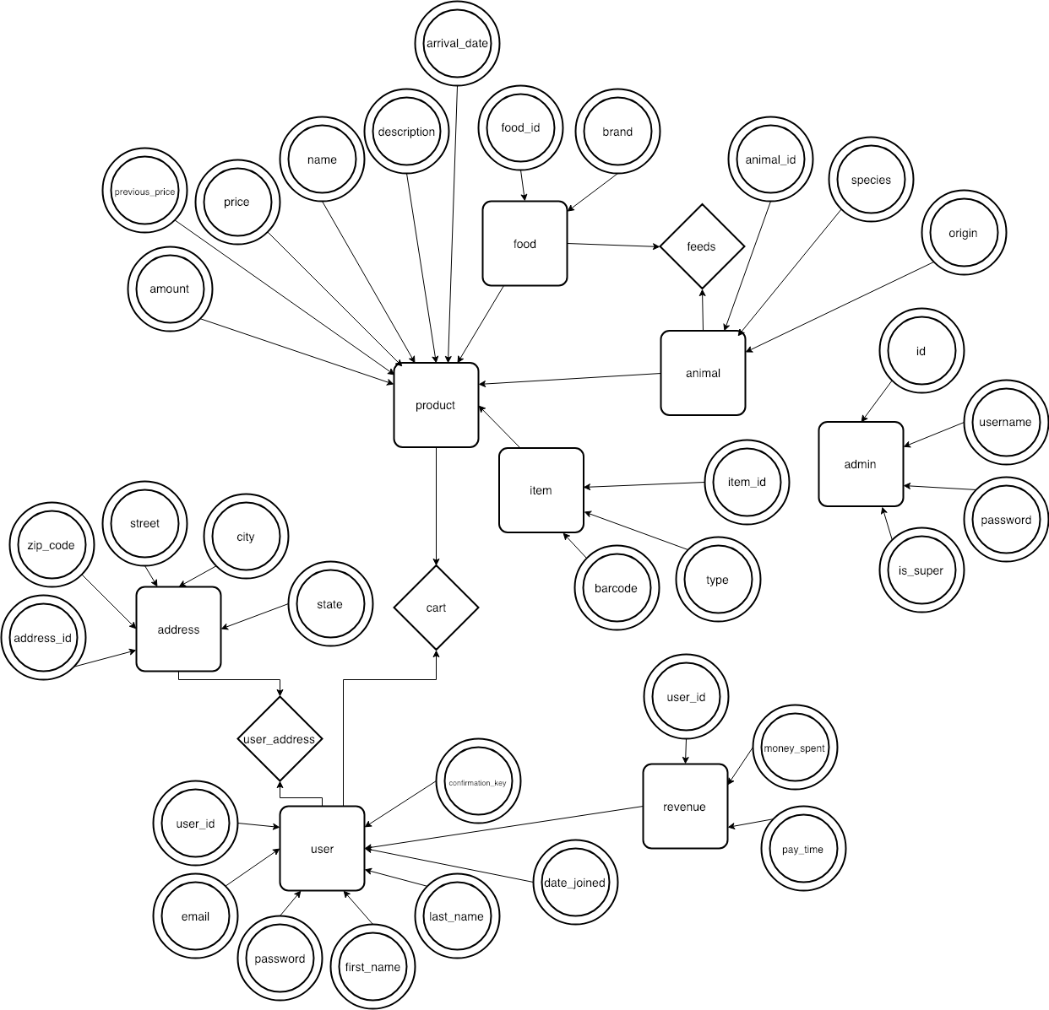

TABLES:

Admin Table:
The Admin table holds information about an admin such as username and password. The table also has an attribute called is_super which is for future work: an admin can add more admins into the table if-and-only-if the admin is a super admin (is_super is set to 1/true). The admin can be uniquely identified with an id, which is primary incremental key.

User Table:
The User table holds the information about a user. The table has basic login information such as email and password, and other information which can be used to contact the person and identify them, such as first and last name. The table also has a date_joined attribute which is a datetime that is set when the user is created in the table (when user registers). The date_joined column is useful when showing users specials after being customers for a time. The last attribute is confirmation_key which is used to email the user after the registration process. The website sends the contents of the confirmation key attribute to the email that was entered, and when the user comes back from the email the contents are cleared and the user is allowed in.

Revenue Table:
The revenue table holds information about user transactions. It contains an auto-incrementing primary key which makes every row unique. The user_id is used to connect the revenue row to a user (who also has a unique id). Following this schema, one User can have many revenue rows, so one user can shop multiple times. The revenue table also has a pay_time attribute which is for admin purposes. The admin can use this attribute to look for earnings between a set of times.

Address Table:
The table holds the address information such as zip code, street, city, and state. A user can have many addresses, and one address can hold many users, so we have a relationship of many to many between the User and Address table using the user_address table.

Product Table:
The product table holds the most valuable information of all tables. It contains an auto-incrementing primary key which makes every row unique. The product table contains previous_price and price attributes. The price attribute show the current price of the product, while the previous_price holds the price before. We decided to do this to show sales when price < previous_price. The amount attribute stores the number of products in stock. The name attribute is used to identify items with real-world objects, such as fish, dog, and shovel. The description attribute stores information about a products, such as condition, height, weight, and color.

Animal Table:
The Animal table has a one-to-one relationship with product. Therefore, an animal is a product and “inherits” all its attributes. Besides the product attributes, Animal has a species_name attribute and origin since some customers want to know the species of an animal and where it came from.

Item Table:
The Item table has a one-to-one relationship with product. Therefore, an item is a product and “inherits” all its attributes. Besides the product attributes, Item has type and barcode attributes. The type attribute can be used to identify what this item can be used for. For example, a shovel can be used for gardening, so its type would be “gardening”. The barcode is a requirements of all items sold.
Food Table:
The Food table has a one-to-one relationship with product. Therefore, a food is a product and “inherits” all its attributes. Besides the product attributes, Food has a brand attribute. This is because many customers care about brands and high quality food for their pet. There is also a many to many relationship between Animal and Food. An animal can eat many foods, and a food can feed many animals. This relationship is expressed with the feeds table; the feeds table holds animal_id and food_id.

MODELS:

Admin Model:
The Admin Model is an ORM(object relational model) used to connect the admin table to the front end. It’s function is to be able to retrieve a row of information from the Admin Table, check and verify an incoming password with one in the Admin Table, create a session(server cookie) that holds the the Admin’s id, and constructs an instance of the Admin ORM that represents the row retrieved from the Admin Table.
public function __Construct($row): Takes a row fetched from the Admin Table as a key-value array and uses it to set the protected variable in the instance of the Admin ORM.

public function getOneById($id): Connects to the database using the getConnection in the Connection Model and executes a mySQL query selecting a row by comparing the Admin Id to the $id. The query returns a key-value array that is made into an instance of an Admin ORM: $admin = new Admin($row). The instance of the Admin ORM, now $admin, is returned.

public function verifyPassword($password): Takes a password and compares it to the password set in the current Admin instance. Returns true if passwords and the same.

public function logIn(): Begins the cookie session for the Admin and stores the id of the Admin instance into the session. This function should be called only after calling verifyPassword($password).

Various get function were used to simply return the information in each protected variable of it’s Admin instance.
User Model:
The User Model is an ORM(object relational model) used to connect the user table to the front end. It’s function is to be able to retrieve a row of information from the User Table, check and verify an incoming password with one in the User Table, create a session(server cookie) that holds the the User’s id, and constructs an instance of the User ORM that represents the row retrieved from the Admin Table.
public function __Construct($row): Takes a row fetched from the User Table as a key-value array and uses it to set the protected variable in the instance of the User ORM.

public function insertUser($post): Connects to the database using the getConnection in the Connection Model and executes a mySQL query that inserts a row into the User table with the information found in the $post array. Returns void once completed.

public function getOneById($id): Connects to the database using the getConnection in the Connection Model and executes a mySQL query selecting a row by comparing the User Id to the $id. The query returns a key-value array that is made into an instance of an User ORM: $user = new User($row). The instance of the User ORM, now $user, is returned.

public function verifyPassword($password): Takes a password and compares it to the password set in the current User instance. Returns true if passwords and the same.

public function logIn(): Begins the cookie session for the User and stores the id of the User instance into the session. This function should be called only after calling verifyPassword($password).

public function getCartProducts($productf_id): Inserts into the Cart table a row made up of a product_id and a user_id if the row does not yet exist in the Cart table. If the insert modified any row it returns true and false if it didn’t.

public function getCartProudct($product_id): Delete from Cart table a row where the $product_id is equal to the cart.product_id.
Various get functions were used to simply return the information in each protected variable of it’s User instance.

Various set functions were used to simply update the information in the table using a query Updating User where the id was the same as the id of the instance of User.
Revenue Model:
The Revenus Model is an ORM(object relational model) used to connect the revenue table to the front end.
public function __Construct($row): Takes a row fetched from the Revenue Table as a key-value array and uses it to set the protected variable in the instance of the Revenue ORM.

insert($money_spent): Contains a parameter $money_spent which is variable of type double. Connects to the database using the getConnection in the Connection Model and executes a mySQL query to insert the money the user has spent and remove all products from user cart. This function only takes one parameter as it gets the user id from User::current()->getId() and pay_time is the SQL function NOW(). Returns true if query was successful and false if it wasn’t.

fromDateToDate($from, $to): Contains parameters $from and $to which are both strings in date format (“MM/DD/YYYY”). Connects to the database using the getConnection in the Connection Model and executes a mySQL query to get all revenues between $from and $to, while also joining every revenue row with a user through user_id.

Various get functions were used to simply return the information in each protected variable of it’s Revenue instance.

Address Model:
The Address Model is an ORM used to connect the address table to the front end. It’s function is to create and insert a new Address into the Address table, add a row to the User_Address, and retrieve a row from the Address table.
public function __Construct($row): Takes a row fetched from the Address Table as a key-value array and uses it to set the protected variable in the instance of the Address ORM.
public function getOneById($id): Connects to the database using the getConnection in the Connection Model and executes a mySQL query selecting a row by comparing the Address Id to the $id. The query returns a key-value array that is made into an instance of an Admin ORM: $address = new Address($row). The instance of the Address ORM, now $address, is returned.
public function insertAddress($post): Connects to the database using the getConnection in the Connection Model and executes a mySQL query that inserts a row into the Address table with the information found in the $post array.
public function addManyToManyUserAddress($u_id): Connects to the database and execute as mySQL query that inserts a row into the User_Address table made up of $u_id and ‘LAST_INSERT_ID()’ which should be the index of the of the last address inserted (function must be called right after making address).
public findOneAddress($uid): Connects to the database and executes to mySQL query. The first is to find the address_id in the User_Address table by compaing $uid to the User_Address.user_id. It returns only one id. The second query uses the address_id from the first query to find the address in the Address table. The query returns a key-value array that is made into an instance of the Address ORM. $address= new Address($row2).The instance of the Address ORM, now $address, is returned.
Various get functions were used to simply return the information in each protected variable of it’s Address instance.

Product Model:
The Product Model is an ORM used to connect the product table to the front end and handle the parent child relationship between the Product table and three children tables. It’s functions include inserting, deleting, and updating a product in the Product table, finding all products on sale, searching for a product, finding a product by id, and retrieving all products in the Product table.
public function __Construct($row): Takes a row fetched from the Product Table as a key-value array and uses it to set the protected variable in the instance of the Product ORM.
public function findAll($table = null): Connects to the database and executes mySQL query to retrieve all rows from Product table when $table is equal to null. However, when used by a child, $table will be set to the name of the table and will be included in the query as an additional tables in From. Thereby findAll can retrieve all information of product and information in relation to its child. The query return an array made into an instance of the ORM that called it, be it the children or parent. As in $class = $ucfirst($table). $class is the name of the table passed in, creating an instance of that model. Then $arr = new $class($row) but with $arr being pushed into repeatedly. $arr is returned.
public function findById($id): Connects to the database and executes mySQL query to select a row from a product, animal, food, and item table where the product_id = $id and if any of the other childrens table id is equal to the $id. Once the query returns a key-value array into $row, the $id is again compared to the following: $row[‘animal_id’], $row[‘food_id’], and $row[‘item_id’]. This will determine what kind of product has been returned and what instance must be created out of $row. Additionally if an animal, getFoodInfo must be called; if a food, getAnimalInfo must be called. The child instance the parent is related to will be returned.
public function search($text): Connects to the database and executes mySQL to query the product name and description. The search works as a ‘LIKE search’ by querying tables in a manner of ‘contains’. So the function looks for a string $text inside either name or description (doesn’t have to start or end with $text).
public function findSales(): Connects to the database and executes mySQL query to select rows from the Product table where the price is less than the previous price. All key-value arrays are then pushed into an array that is returned.
public function deleteAllById($id, $home): Connects to the database and executes mySQL query to delete a product from product where the product_id is equal to the $id. Once executed, the deleteProductImage($id, $home) function is called to delete the image associated with the product from the folder images.
Various get functions were used to simply return the information in each protected variable of it’s Product instance.

Animal Model:
The Animal Model is an ORM used to connect the animal table to the front end and is child that extends the product model. It’s functions include all those of product, and adding many to many feeds, getting four new arrivals, and getting food info pertaining to the animal.and updating a product in the Product table, finding all products on sale, searching for a product, finding a product by id, and retrieving all products in the Product table.
public function __Construct($row): Takes a row fetched from the Food Table as a key-value array and uses it to set the protected variable in the instance of the Food ORM.
public function addManyToManyFeed($id, $feeds): Connect to the database and execute mySQL query where it first deletes everything in feeds with an animal_id of $id. Then it inserts into feeds the the food ids found in $feeds with the $id.
public function getFoodInfo($id): Connects to the database and executes mySQL to query the Animals that have a many to many relationship with the animal where animal_id = $id. The function first grabs all the food ids in the feeds relationship, and then fetches the food that have any id in that set. Returns a list of Food instances.
public function allInfoById($id): Connects to the database and executes mySQL query to search for an Animal with a certain id, and return the join product of the product parent with the same id. Returns an Animal instance.
Item Model:
The Item Model contains information about all the items that are currently being stored in the database

Food Model:
public function __Construct($row): Takes a row fetched from the Food Table as a key-value array and uses it to set the protected variable in the instance of the Food ORM.
public function getAnimalInfo($id): Connects to the database and executes mySQL to query the Animals that have a many to many relationship with the food where food_id = $id. The function first grabs all the animal ids in the feeds relationship, and then fetches the animals that have any id in that set. Returns a list of Animal instances.
Various get functions were used to simply return the information in each protected variable of it’s Food instance.

- System Design
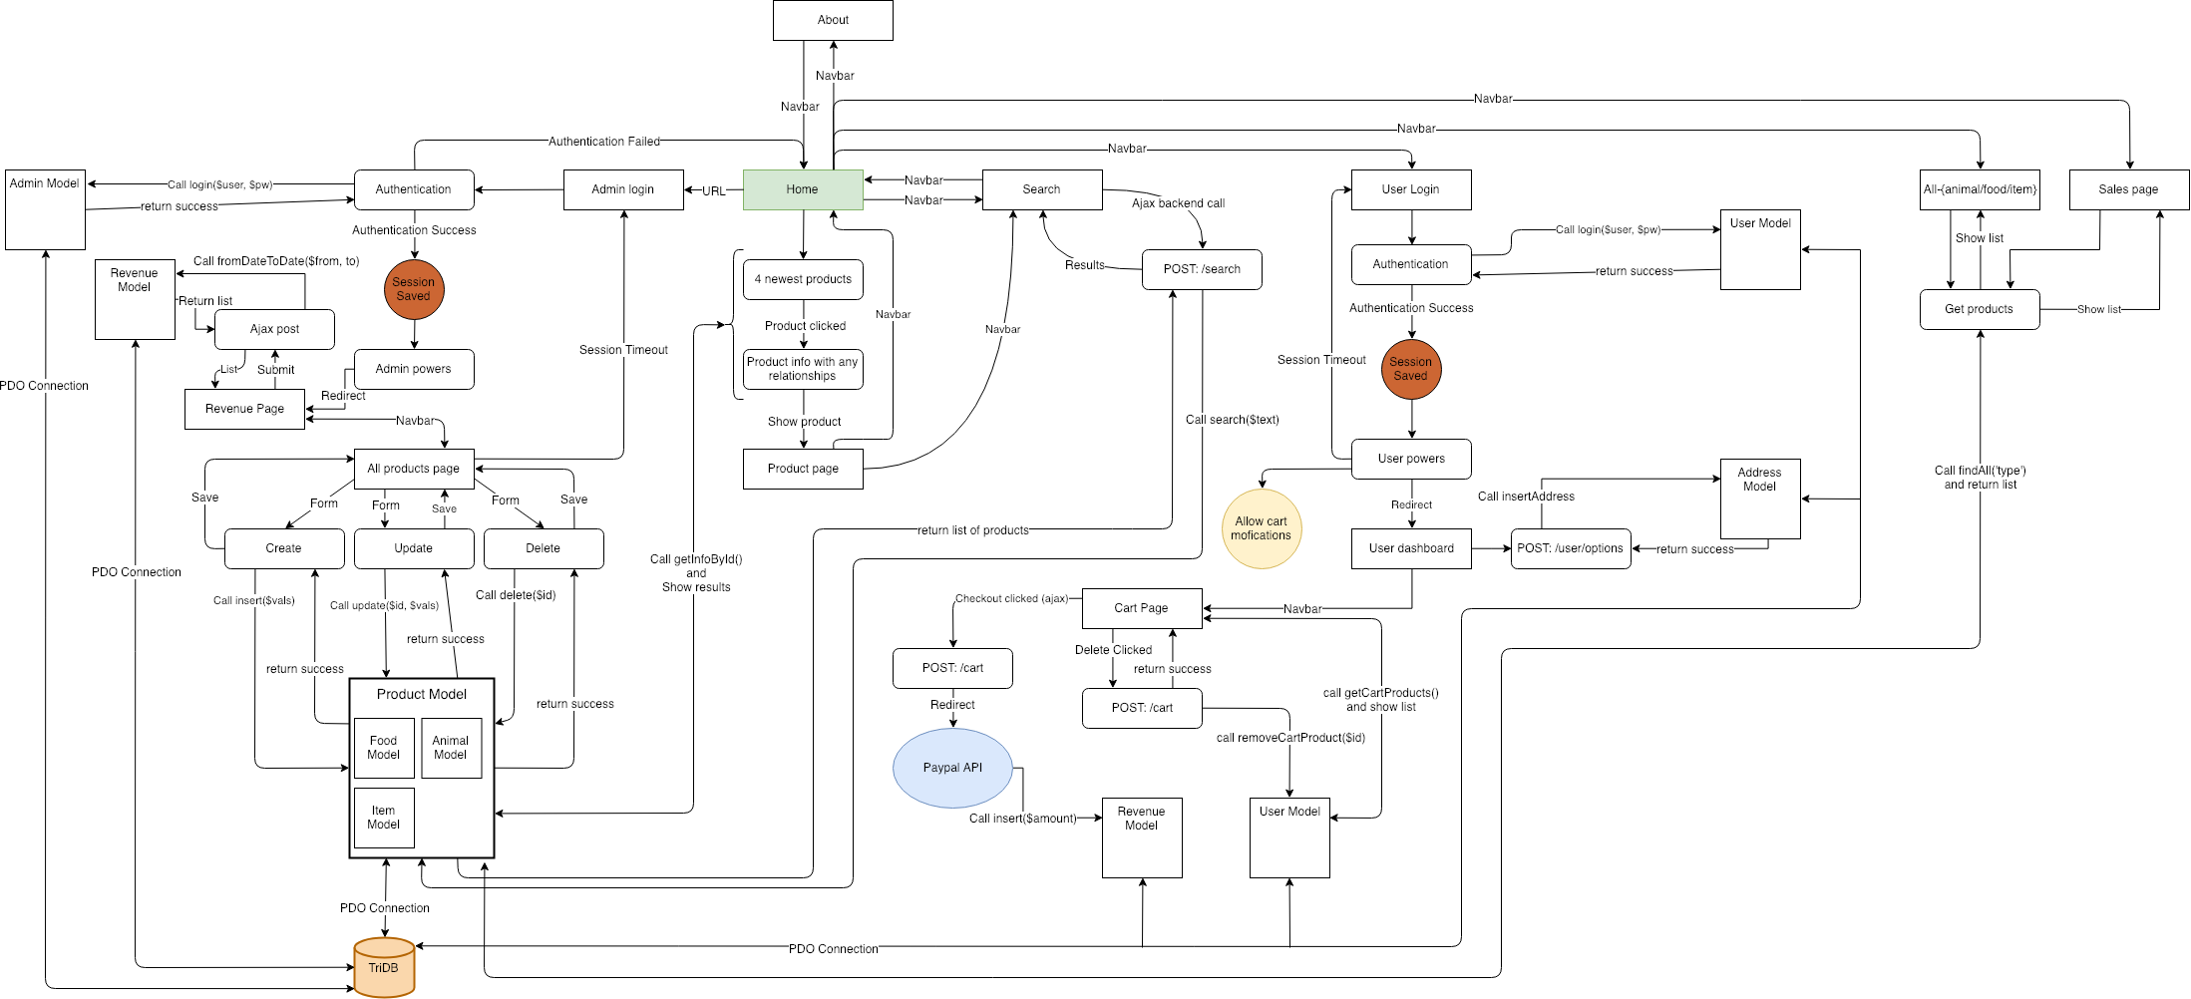

Brown circles = Sessions
Orange Cylinder = database
Blue oval = APIs
white rectangle = views
White rectangle with rounded edges = backend calls
Large White rectangles = Models

The system design of the entire website spans first from the home page which displays a plethora of information regarding all of the pages that are currently available on the site, through three linked tabs the user is taken to each respective page and the user is able to view all of the products available currently in the database per category, the categories are animals, food, and items which all a part of the base product model. The home page also has a newest animal product pane, where the four newest animals are displayed. The home page and all subsequent pages have a dashboard that include a link to return home, a link for the about page, and a link to the sales page. Embedded in that dashboard is a cart and most importantly a search bar, that the user can use to find items related to the specific keyword they have typed into the search bar. From the home page, the user can login or create an account if they haven’t done so already, through the login link at the top of the home page dash. By signing in, the user is able to view an add to cart functionality that is only available if the user is logged in to the site. By adding items to their cart, the user can checkout and pay for items currently in their cart. This is done by routing the user to PayPal to complete a secure transaction and then bringing them back to the site for payment confirmation.
If the user is an administrator, the user has to access the admin page by manually accessing it. The user will go through authentication and will be taken to a revenue page if the authentication returns a success. Once access has been granted, the administrator is able to manipulate the database tables that extend the Product table and add, edit, or delete products in each respective table.
- Routes
The following is a description of all the routes that connect the website

Admin Routes:

The following is all the routes used by the Admin Controller.

The first route that is used is the login route, which does as it says, it allows the admin to attempt to login by verifying several attributes. The attributes that are tested are whether or not the admin username and password match the username and password that are saved in the database. The first check is whether the username returns as valid admin username otherwise it returns a NULL value and redirects the user to the home page. There is check to see if the password that was entered matches the hashed password found in the database. If everything checks out, the admin login returns a success and routes to the revenue page on the admin dashboard.

The second route that is used is the showProducts route, which shows a list of all the products that are currently populating the database. This is done by finding all of the products in the products table of the database and listing them in child tables of the base table Product.

The route deleteProduct, is a route that allows the admin to delete products from the child tables of Product, such as, animal, item, and food.

The route editorcreateProduct, is a route that allows the admin to create new products in the child tables that extend Product. This route also allows the admin to go into individual products and edit them accordingly.

The route ajaxGetFood, is a route that makes an ajax call when adding a new animal to the ANIMAL PAGE. This route is what makes the drop down food selection possible when adding a new animal.

The route logout allows the admin to logout of their account while effectively ending the current session in the process.

The route revenue, is a route that displays a page with information about the amount of revenue the website has made by keeping track of all concurrent transactions through PayPal. The route keeps track of the following parameters: user_id to verify which user made the transaction, the amount through the parameter money_spent, and when the transaction was made through the parameter pay_time. A user makes a purchase from the CART PAGE. When the user clicks the submit button on the CART PAGE they are redirected to PayPal where they login and proceed with the purchase. After the purchase has been cleared, the user is then redirected back to the website and is greeted with a confirmation message stating the completion of their purchase.

The final route in the Admin Controller is the setUpRouting route, this route handles the actual routing between pages. When not logged in, it routes the user to the login page, after a successful login, it reroutes to the REVENUE PAGE; the route also sets up cases for when the user is logged in or not.

User Routes:

The following are all the routes used by the User Controller.

The first route is the logout route, this sets up the session cookie for the user, and reroutes them to the login page.

The next route is the paypal route, this route sets up payment functionality through PayPal and makes purchasing products more secure. The route takes the user to the PayPal web page where they can enter their information in order to make a successful and secure purchase. After payment has been received, the user is rerouted back to the checkout cart.

The options route is used primarily during and after the user has set up an account. When the user initially made their account, they were prompted for additional information such as firstname, lastname, and an address. The options route keeps track of every user’s information and allows the user to edit this information at any time.

The dashboard route grabs the user’s address information and uses it to apply the user’s name to the dashboard layout while they are signed in.
The cart route allows the user to add or remove products to his/her personal cart from the tables Animal, Item, and Food which extend the Product table.

The login route allows the user to login or creates a new user account, by checking if the username already exists in the database. If the username exists, it reroutes the user to their dashboard. If the username doesn’t exist, the user is rerouted to a account creation page which requires a firstname, lastname, and address to finalize the accout registration.

The final route for the User Controller is the setUpRouting route, this route takes care of all the routing between the pages the user can access when signed in to their account. The route has several cases for what to do when a user is signed in or not.

AllController Routes:
The following are all the routes used by the AllController.

The first route is the home route, the purpose of this route is to handle the new arrivals section of the home page for the web site.

The next route about, renders all the information found on the about page.

The route search, takes in queries and allows the user to make requests for specific products; this route also renders the information without reloading the page.

The route product, renders all of a product’s information to the site when accessed by the user.

The route allProducts, renders all of the products in their respective pages when accessed by the user.

The route sales, renders all of the products that have been flagged as on sale to the SALES PAGE respectively.

The final route for the AllController is the setUpRouting route, this route handles all of the routing call between all of pages when accessed by the user.
ToDO finish describing routes found in other contollers

- Implementation
USER INTERACTIONS

The HOME PAGE is the first thing that the user will see.
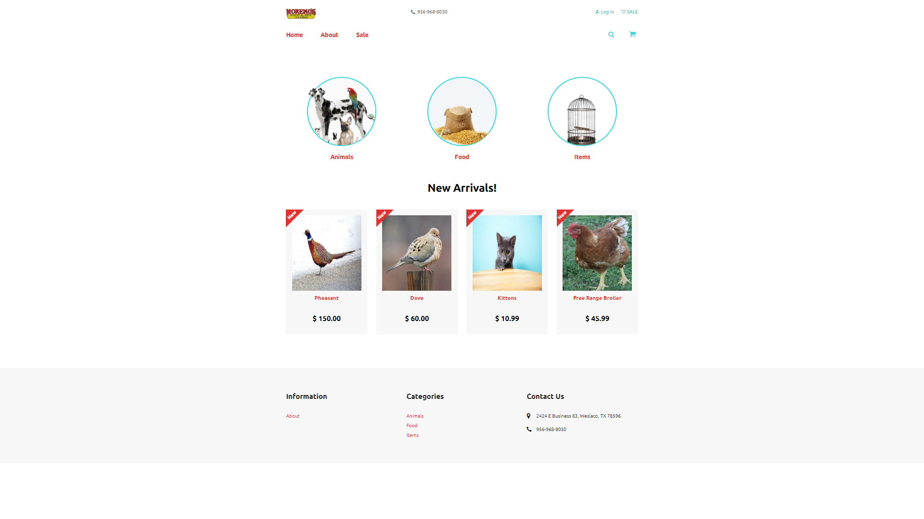
From the HOME PAGE, the user will be able to navigate to several other pages that include, the ANIMAL PAGE, FOOD PAGE, ITEM PAGE, ABOUT PAGE, SALE PAGE, and also make an account through the LOGIN PAGE. There is also a CART PAGE that holds the items that a user wants to purchase, the CART PAGE has PayPal functionality that will take care of all transactions securely. The HOME PAGE is the hub for the entire website and allows the user easy navigation between pages on the site.
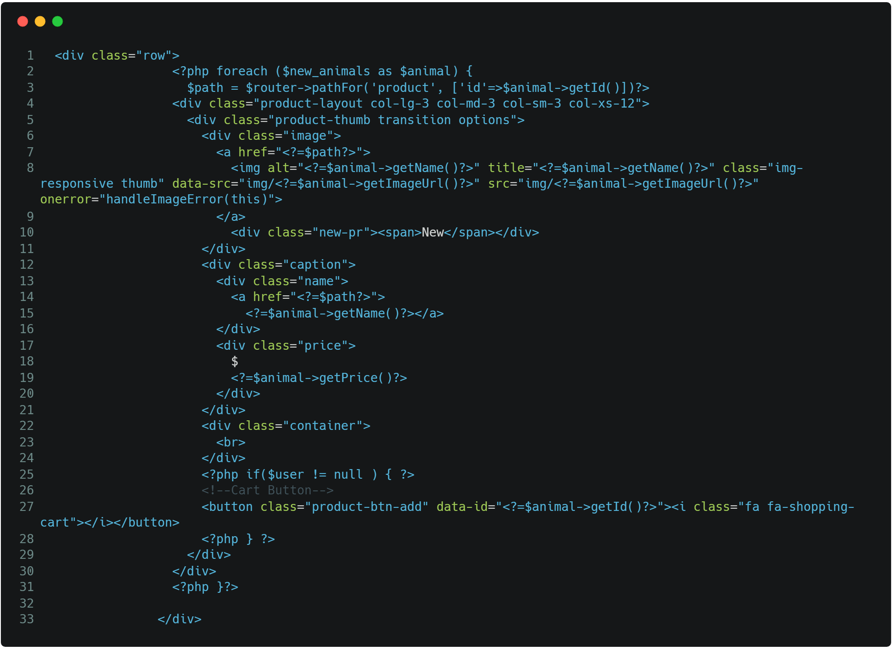
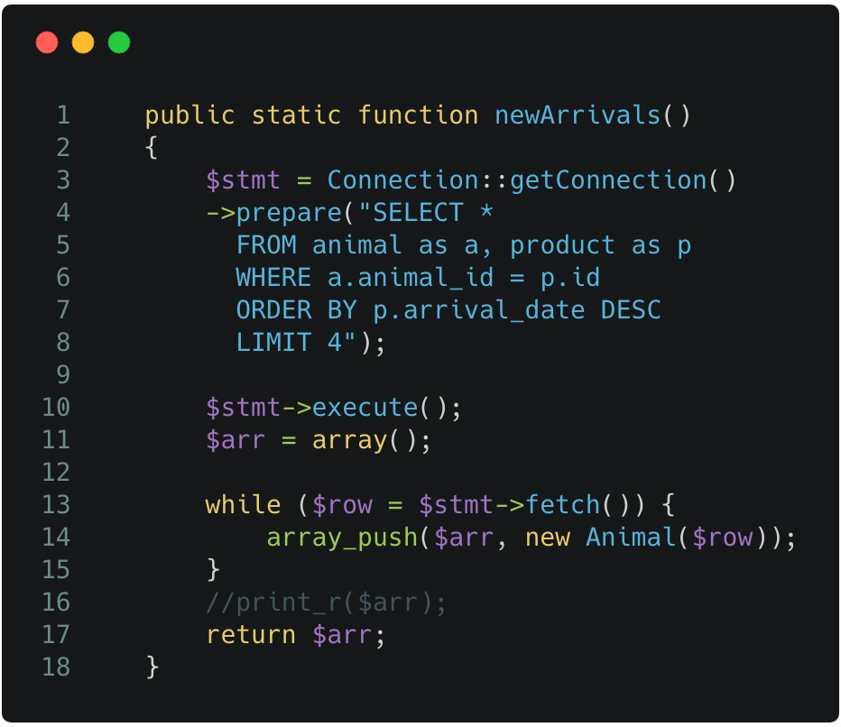
e.g. code to find new arrivals e.g. to print new arrivals
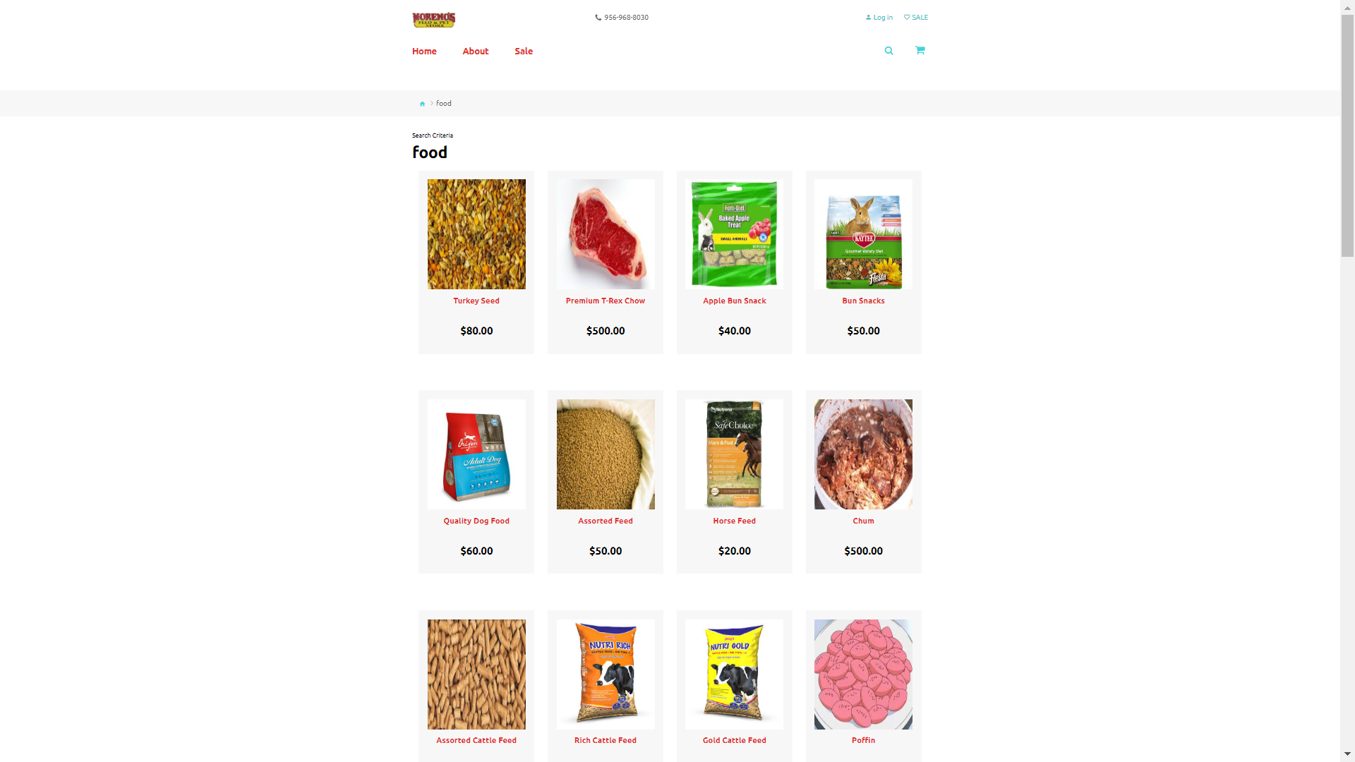
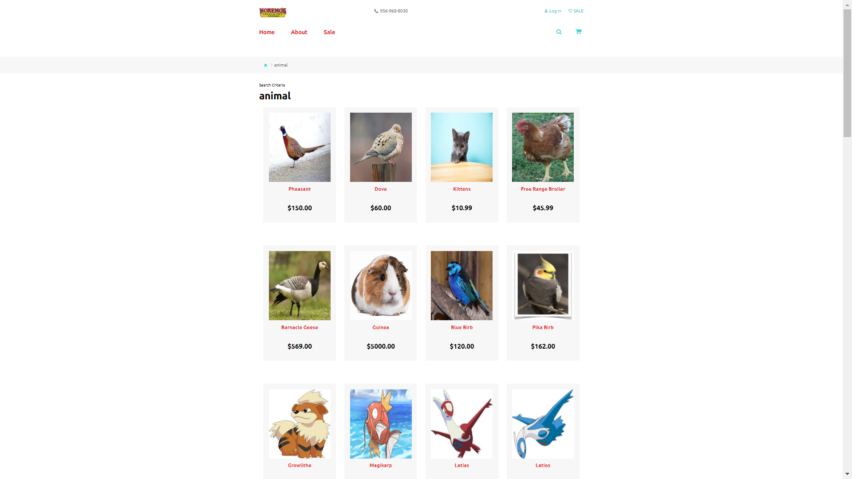
The All-{type} PAGE holds a list of all the currently available products in the database of that certain type. From newest to oldest, the products are listed with their name and price.
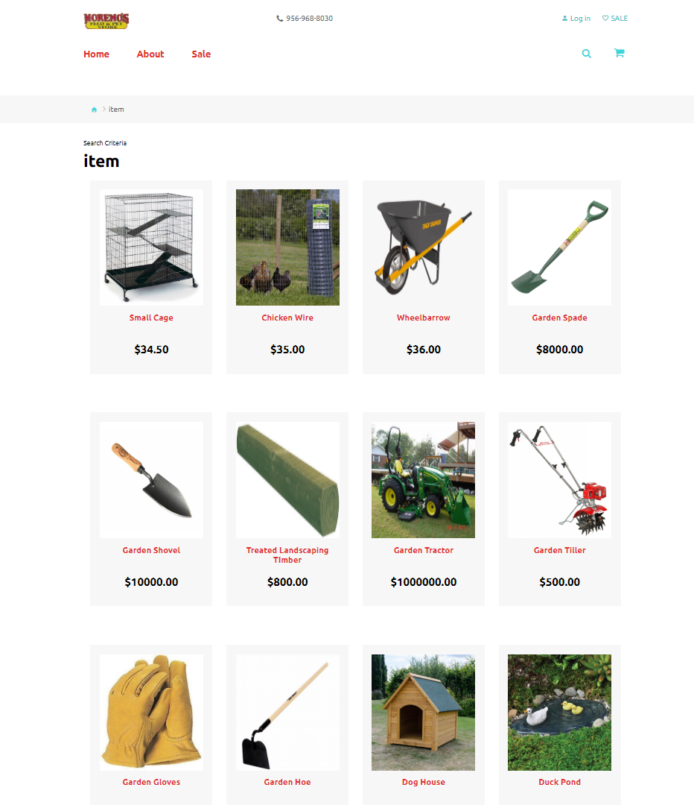

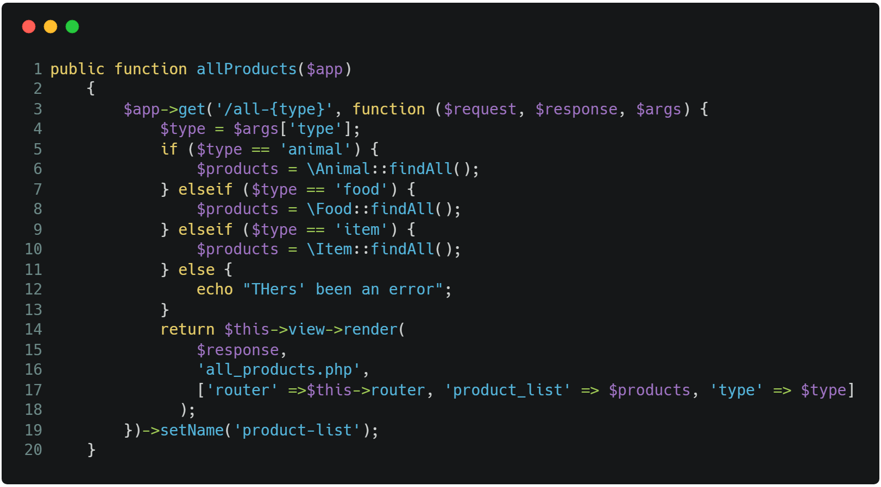
e.g. code for routing to all-{type}
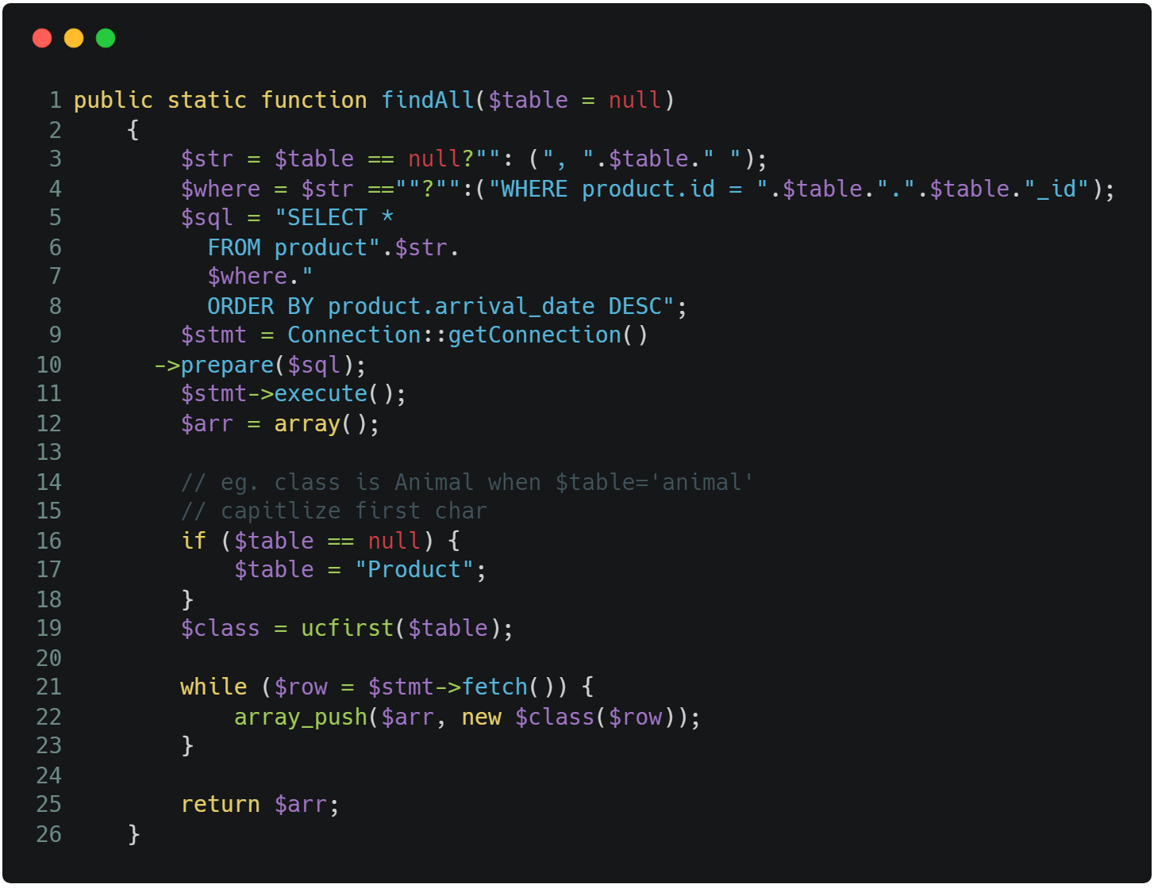
e.g code for findAll() in product model
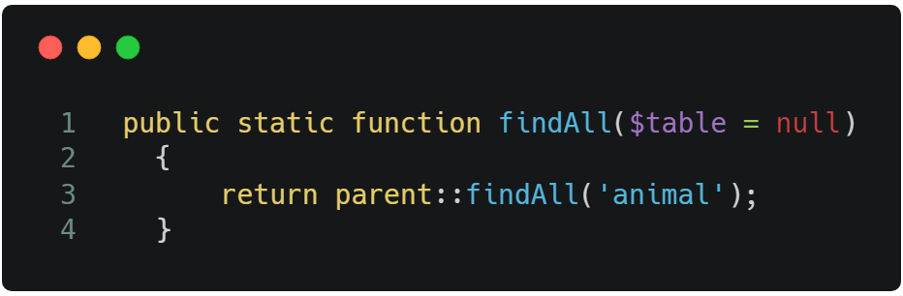
e.g. child using parent function
e.g. listing all products on all-{type} page

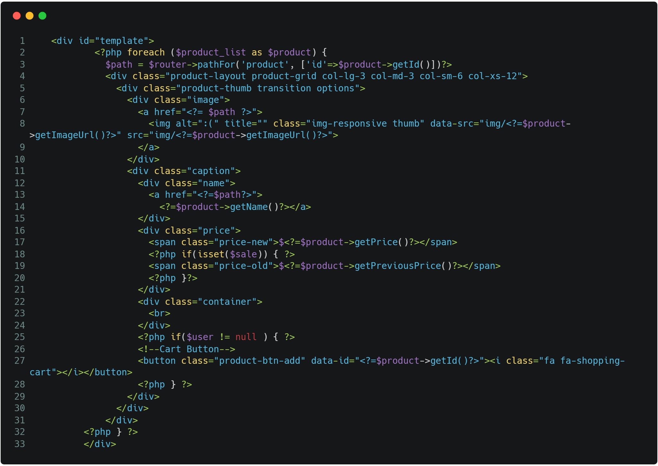

The Sales page shows products that have been reduced in price
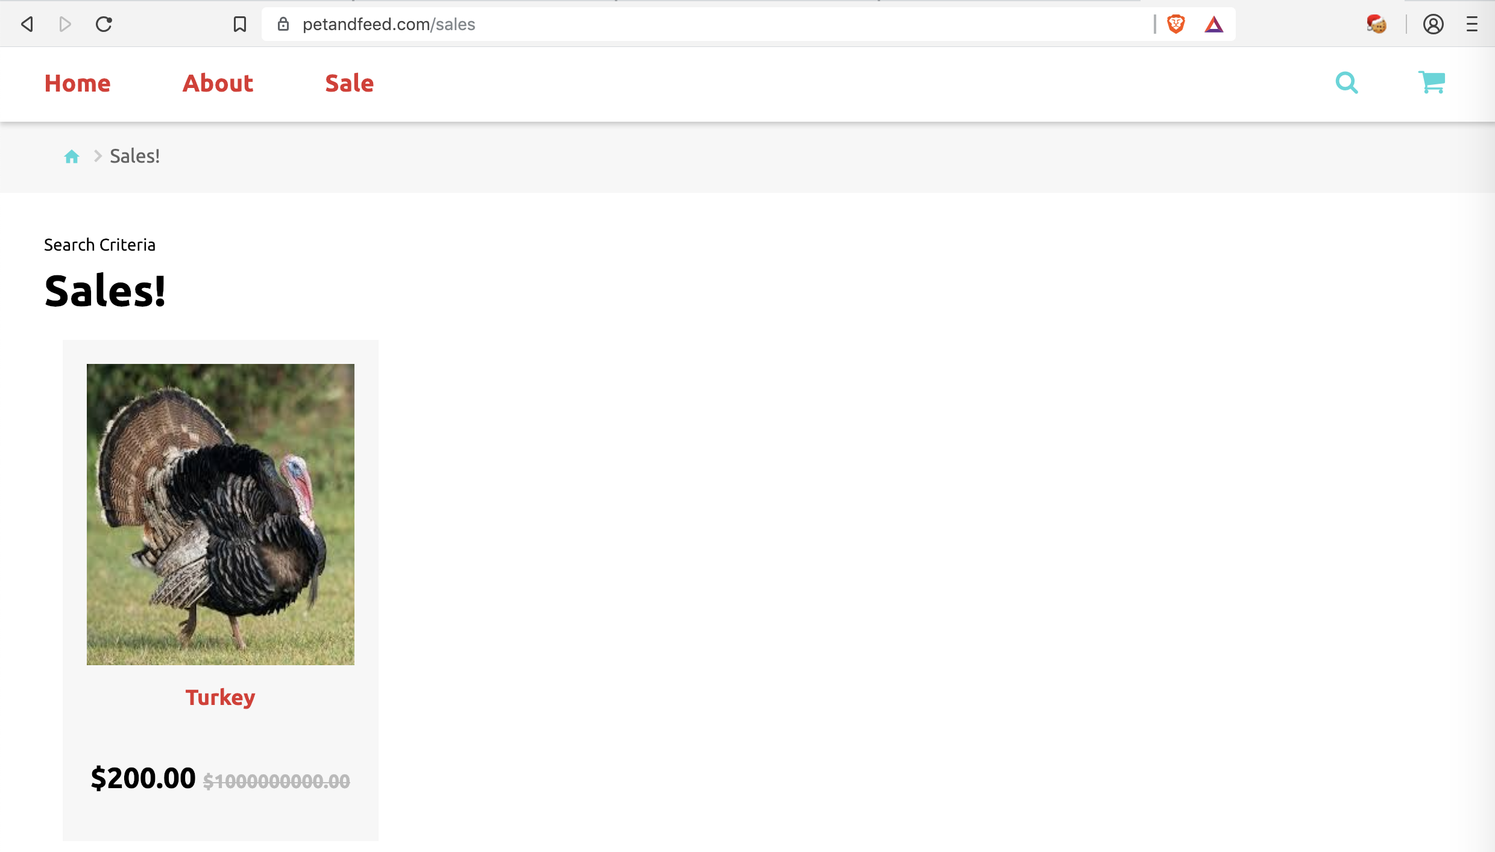

Code to show products that are on sale:
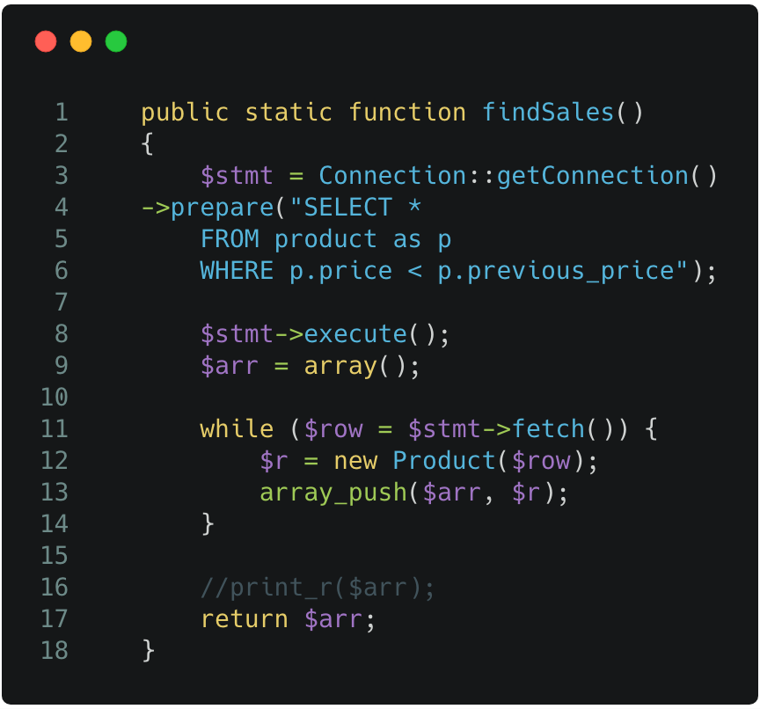

The USER signs up for an account and is granted access to the CART PAGE, this is the only way to make purchases from the website.
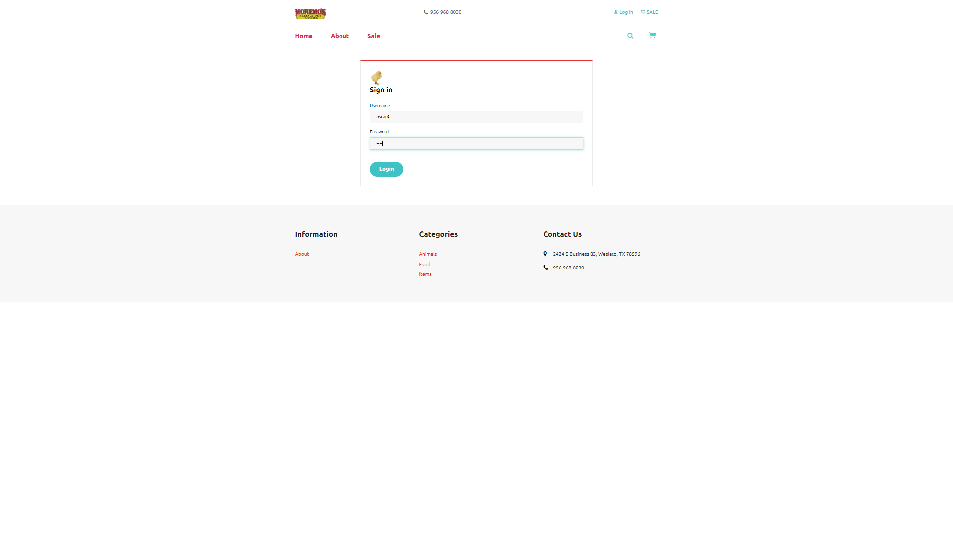
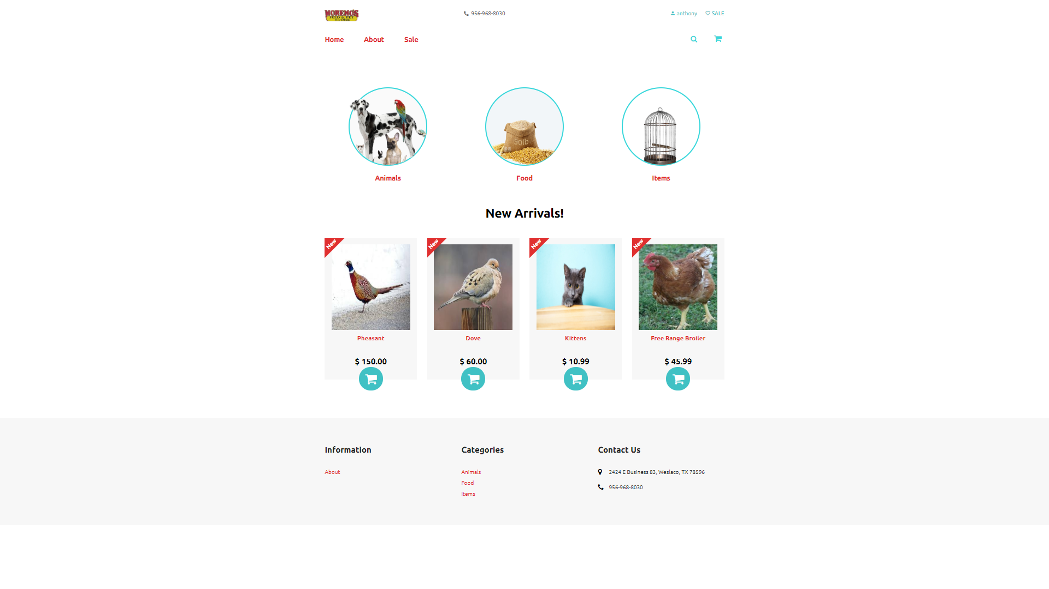

After the user hits the login button, the user is redirected to another page where the user will input some basic information. This information will be used to keep track of the user’s address. After adding their information, the user will hit the confirm button and will gain the ability to access items to add to their personal cart.

e.g. of user routes | e.g. creating user address
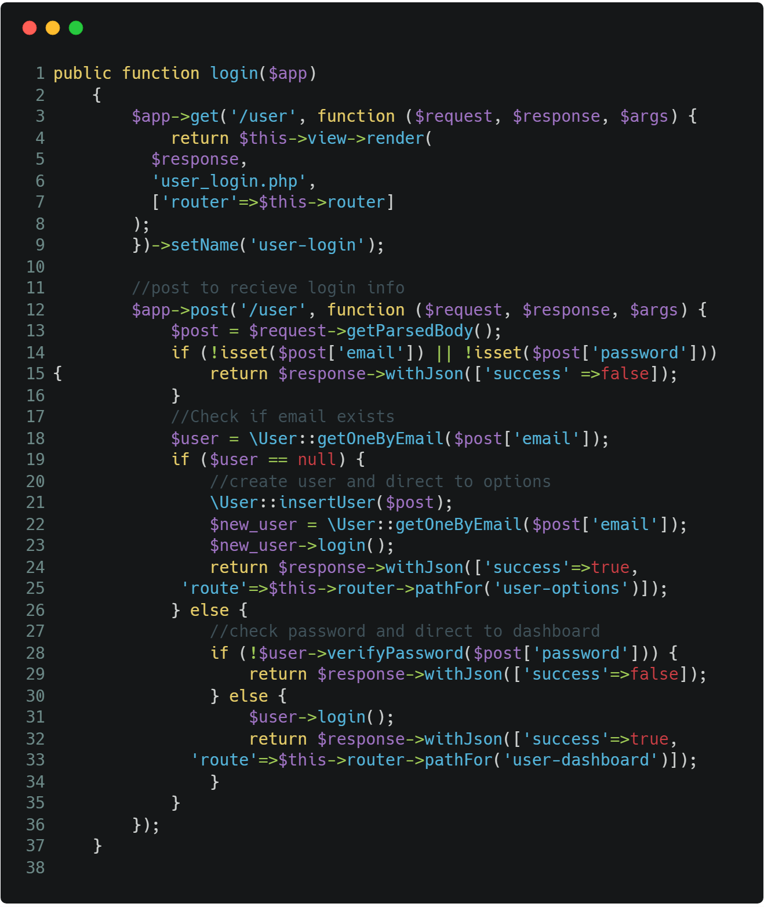 | 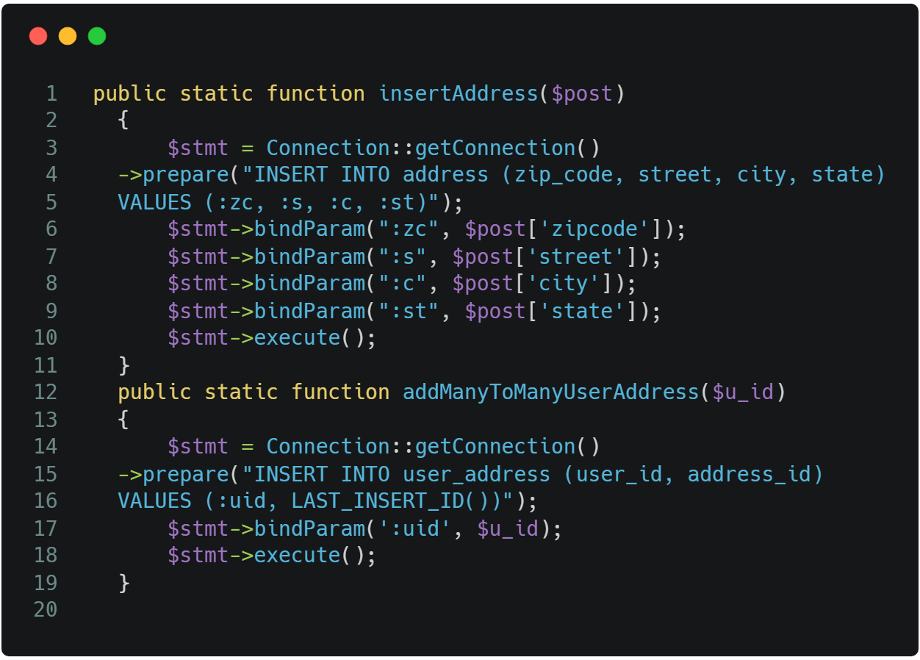

Animal, Food, and Item are the products that can be purchased from and added to the CART PAGE after making an account with the website.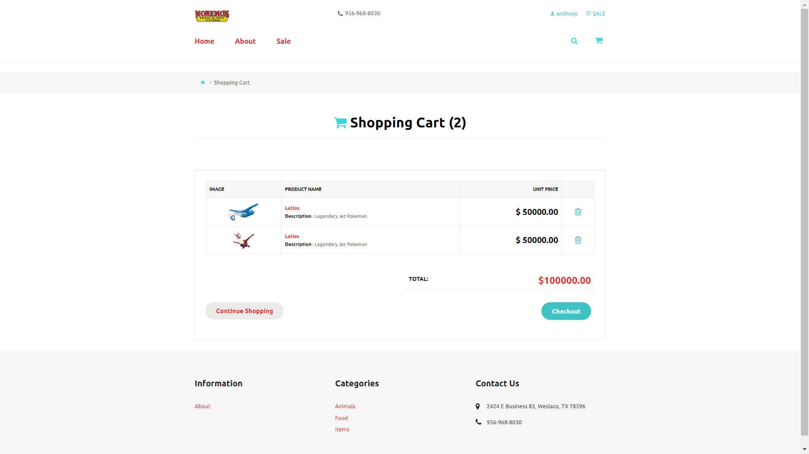
From the CART PAGE, the user can check out all the items in their cart and will be redirected to PayPal.
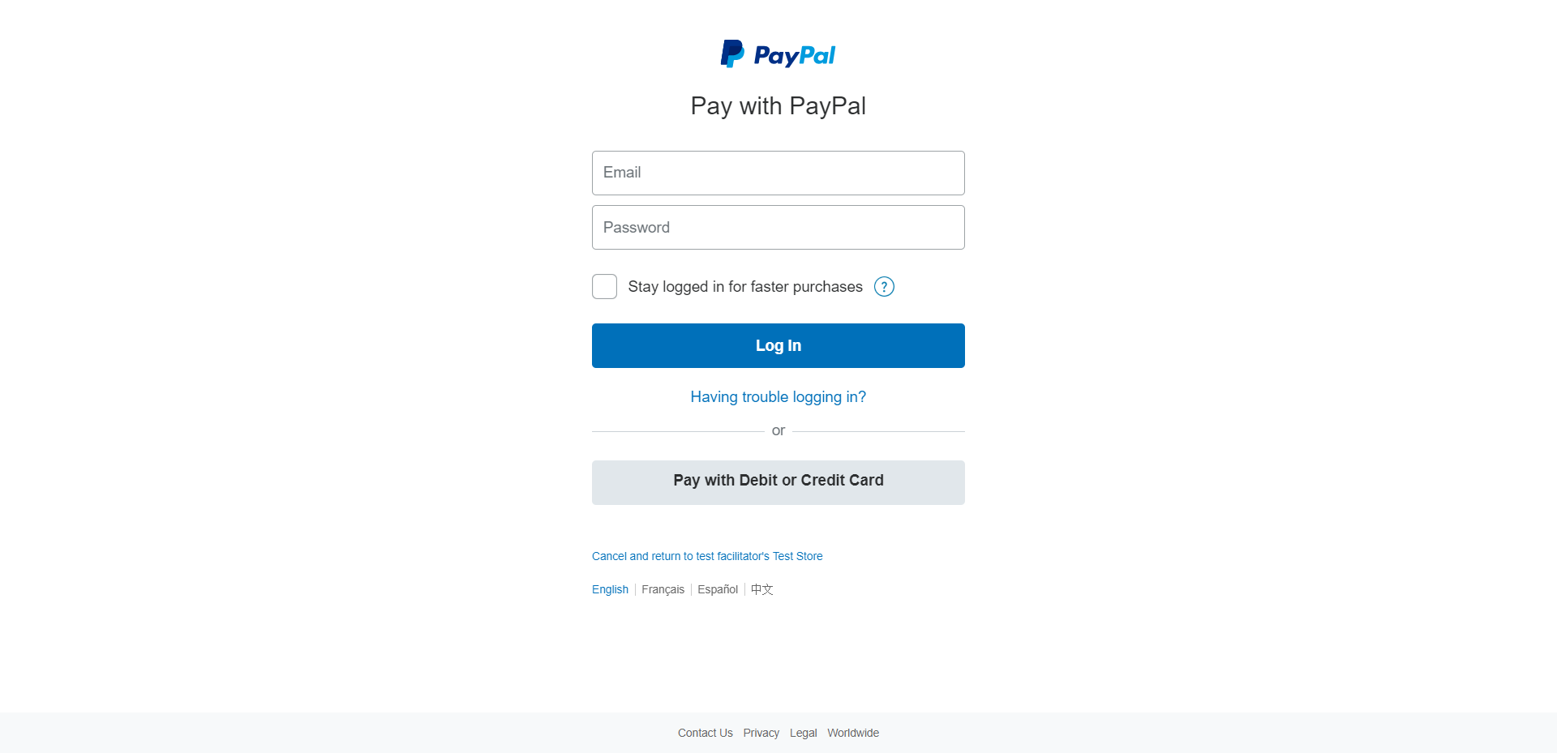

Code to call PayPal API: | Code to get the PayPal API result:
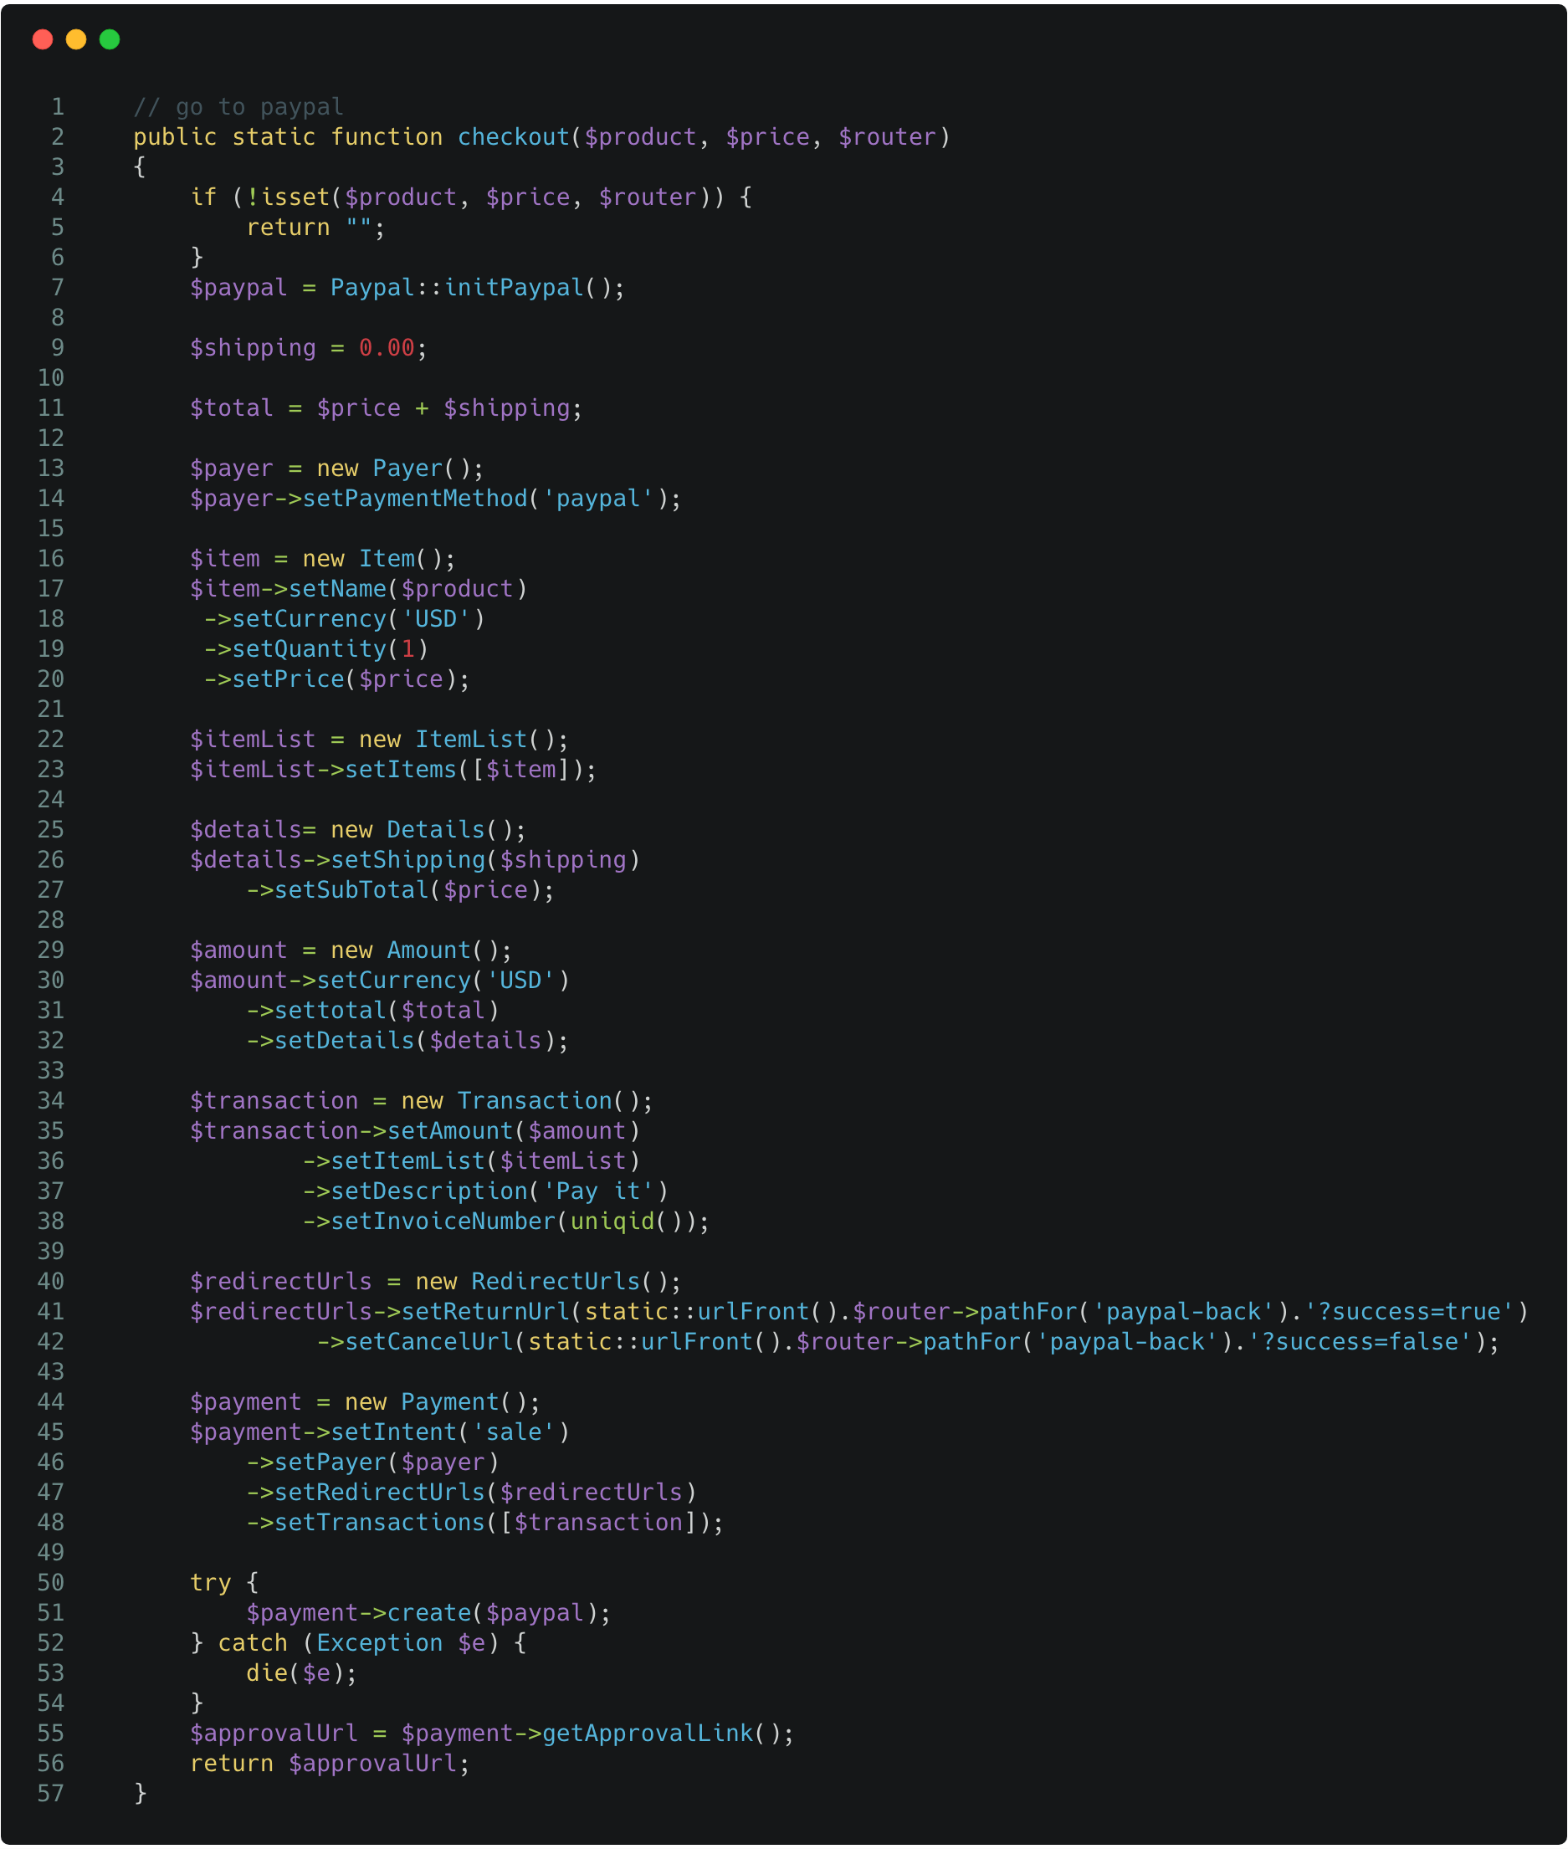 | 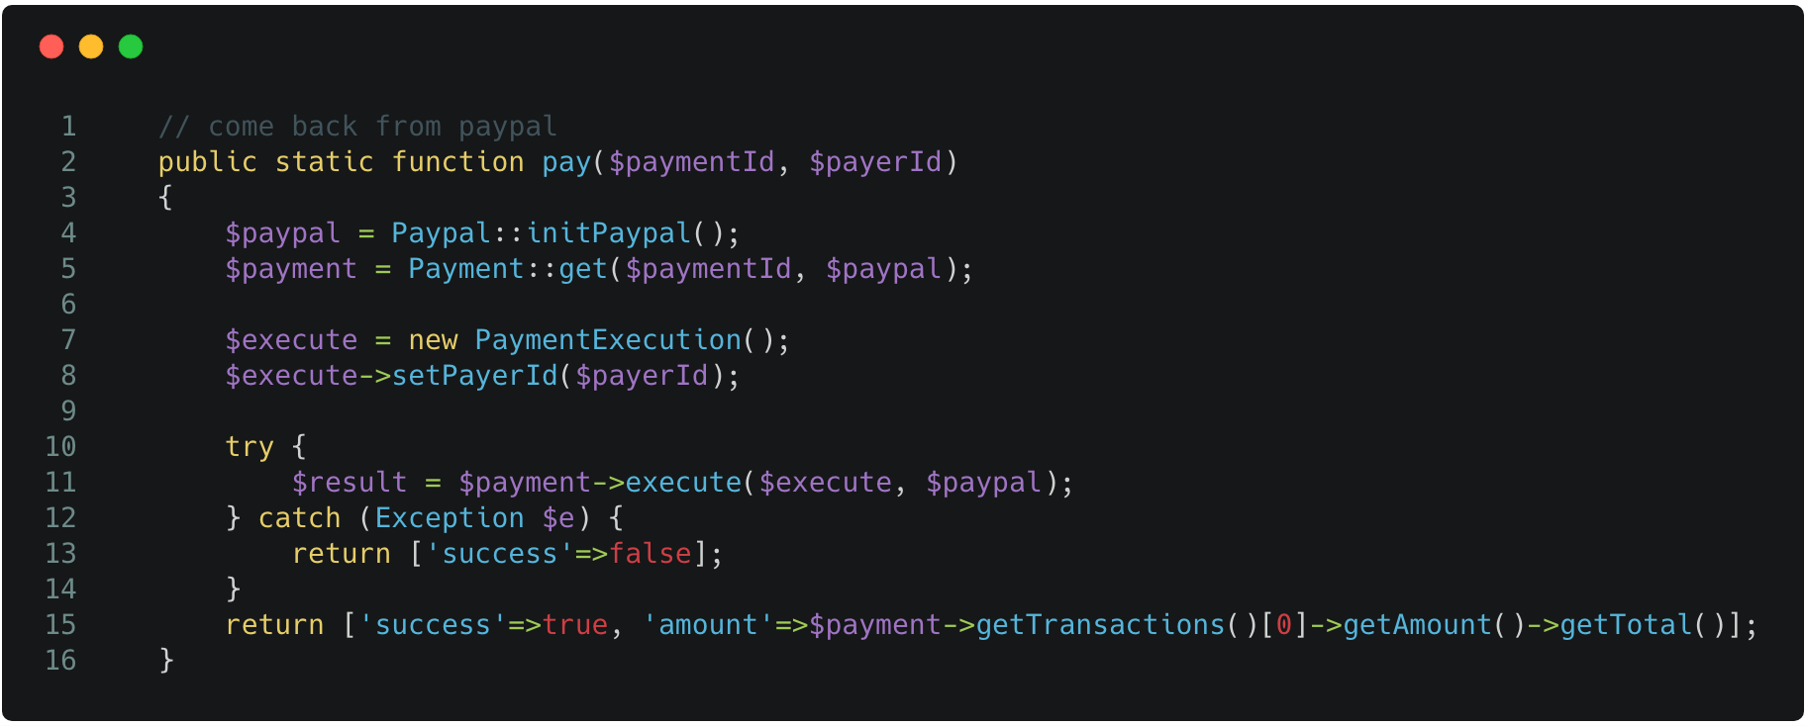

After confirming the payment, the user will be redirected back to the checkout page and will be greeted with a message stating the receipt of the transaction
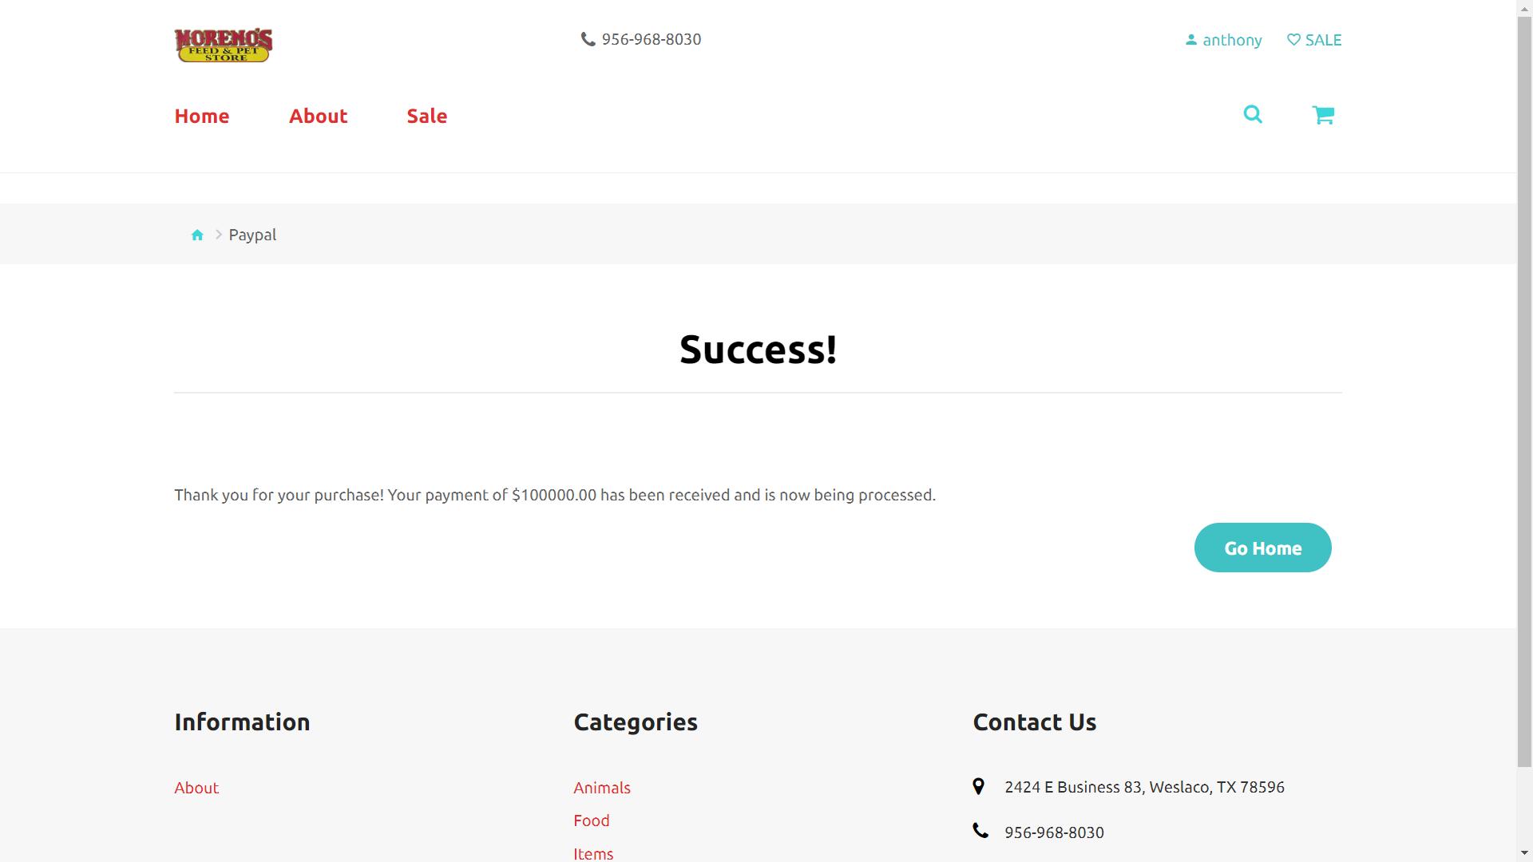

Code to insert value into Revenue Table and clear user cart:
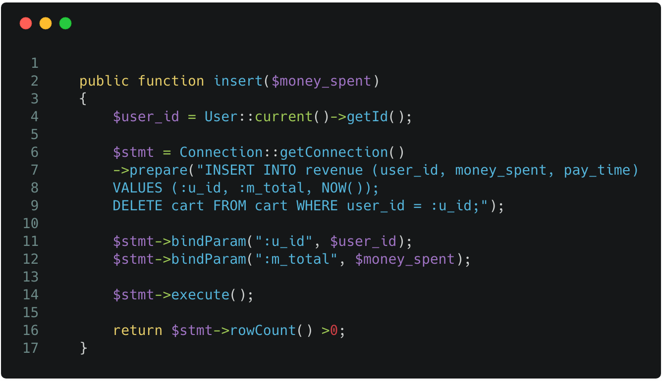

ADMIN INTERACTIONS

The ADMIN must sign in from the ADMIN LOGIN PAGE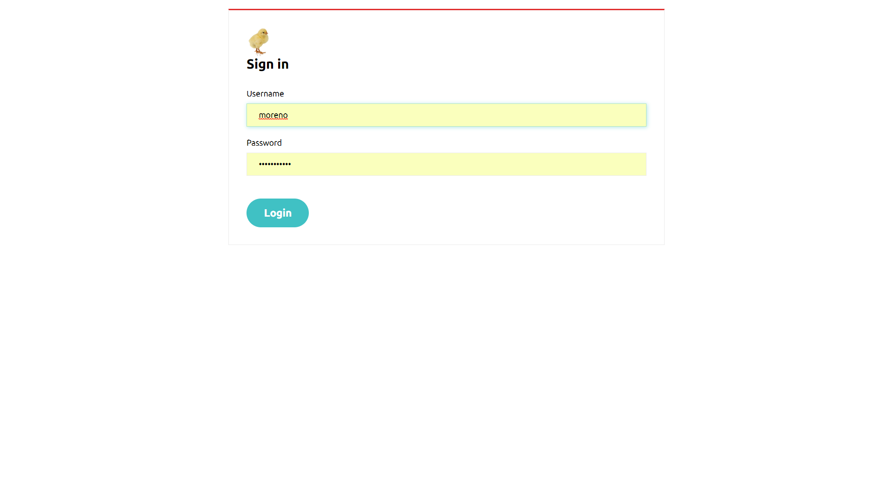

Code to sign in: | Code to check if admin is still signed in:
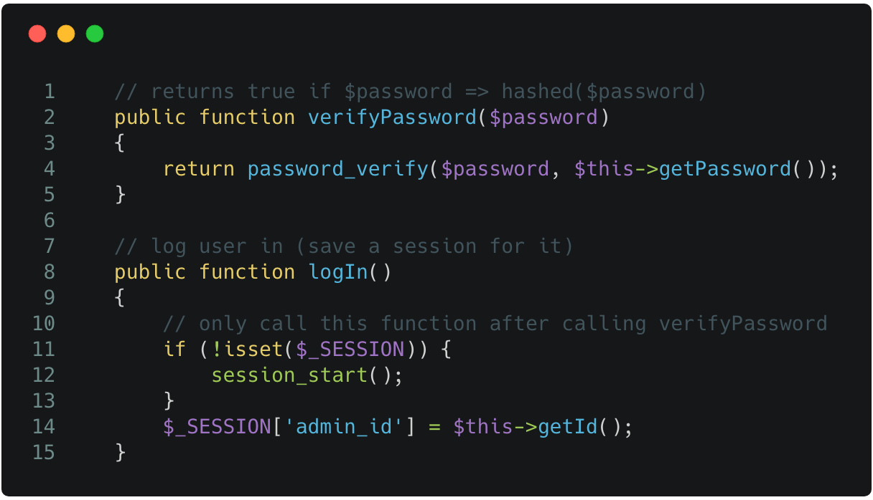 | 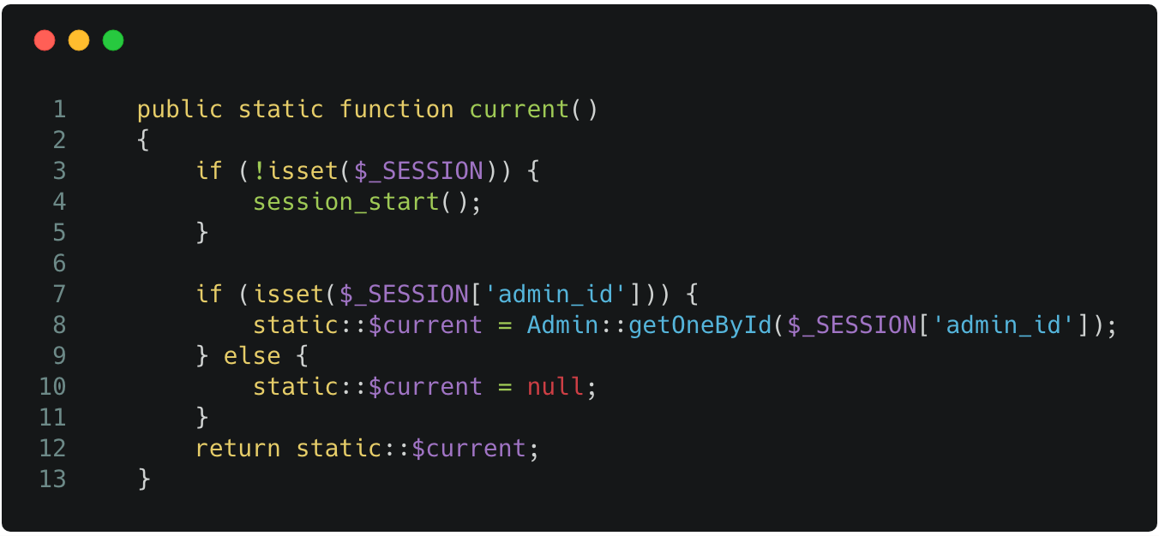

The ADMIN logs in and is shown the REVENUE PAGE
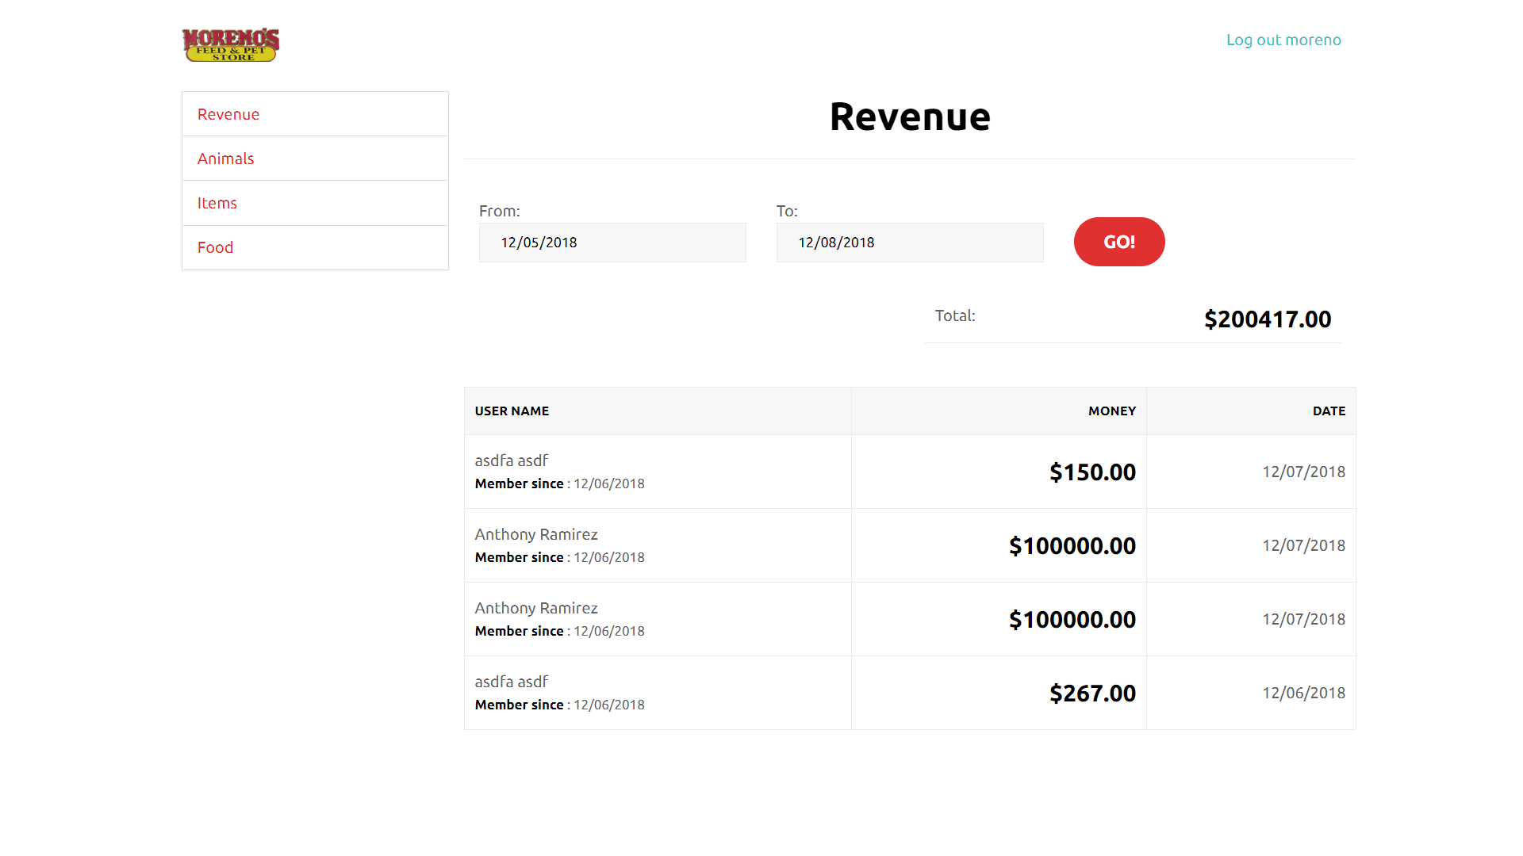
The administrator is able to select the date for which to start the revenue report and where it ends. The REVENUE PAGE helps keep track of all current transactions that are made and organizes the transactions by date. The transactions also keep track of which user made the purchase by keeping the user’s user_id.

Code to get revenue:
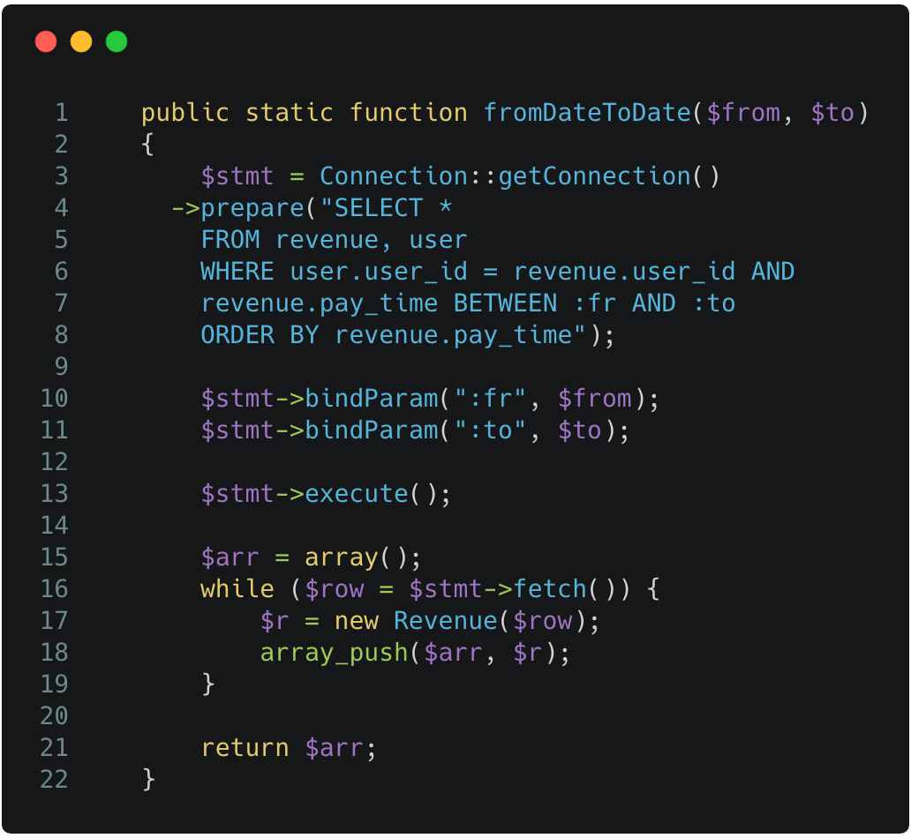

ANIMAL, ITEM, FOOD PAGE(CREATE, EDIT, DELETE)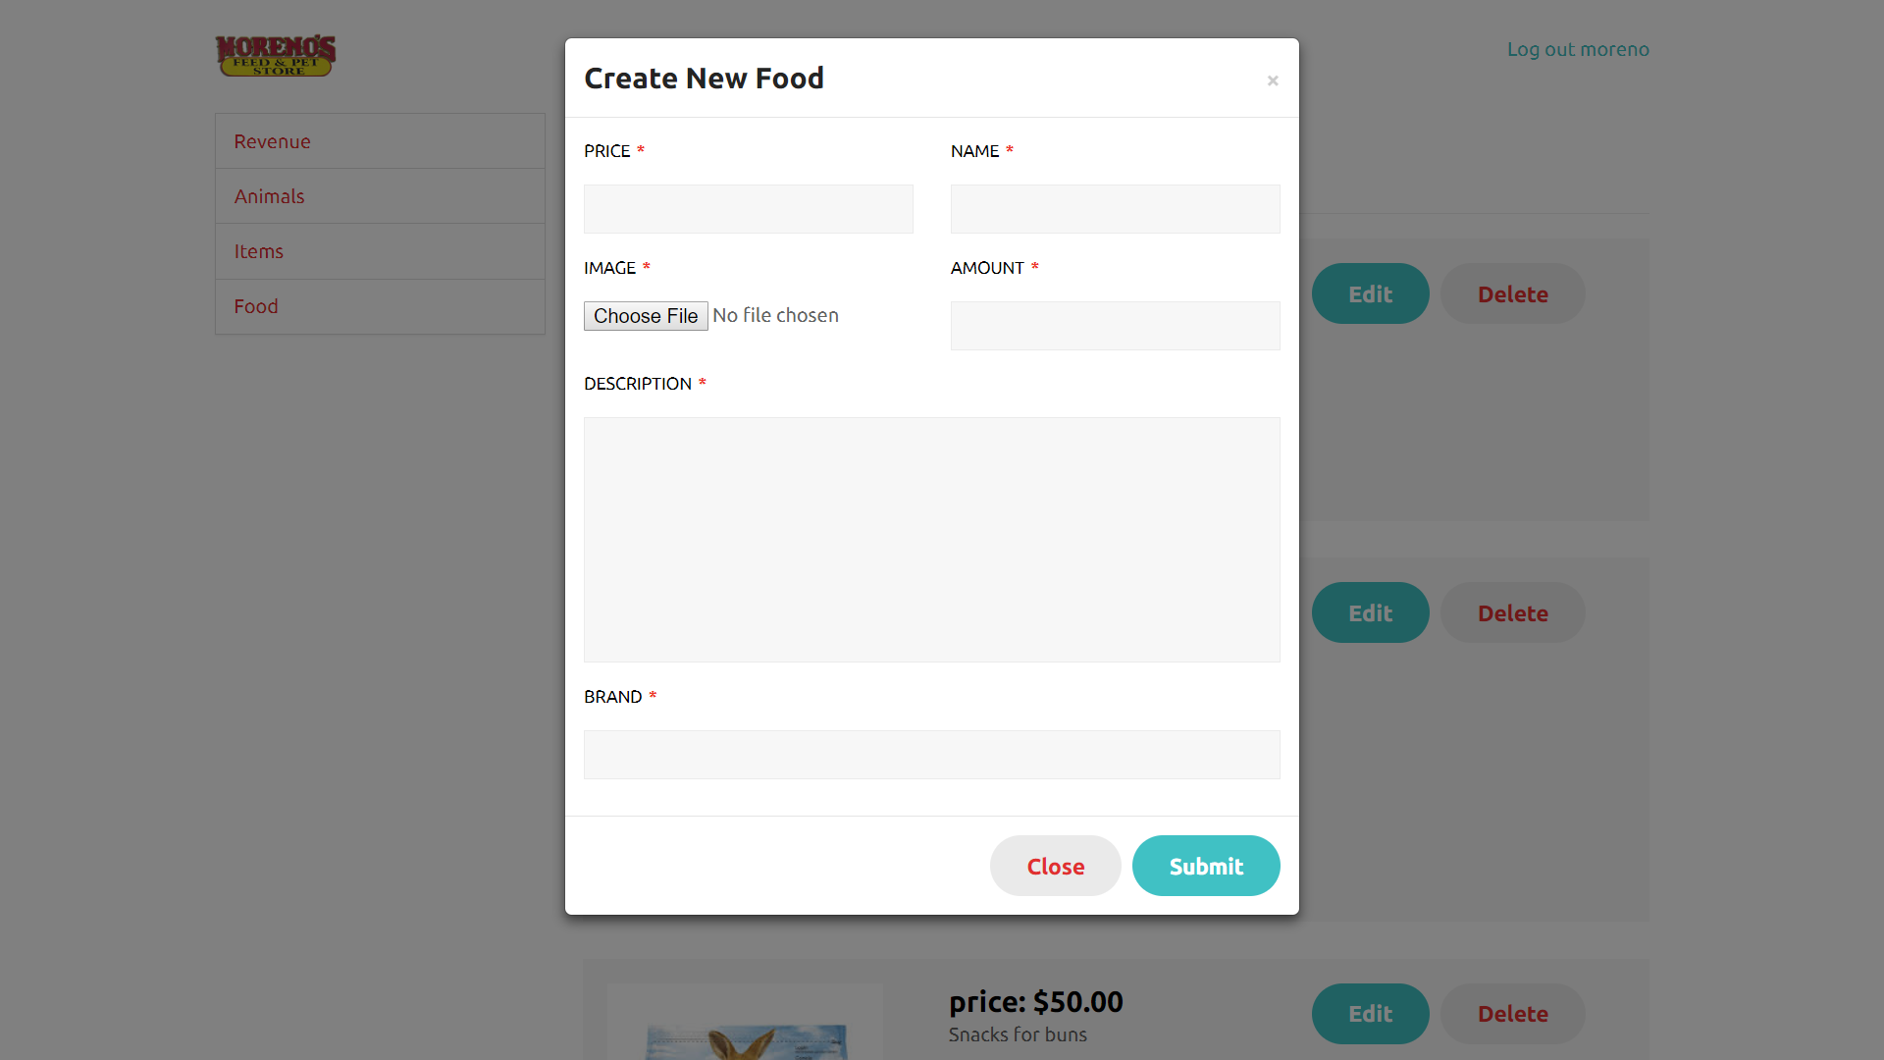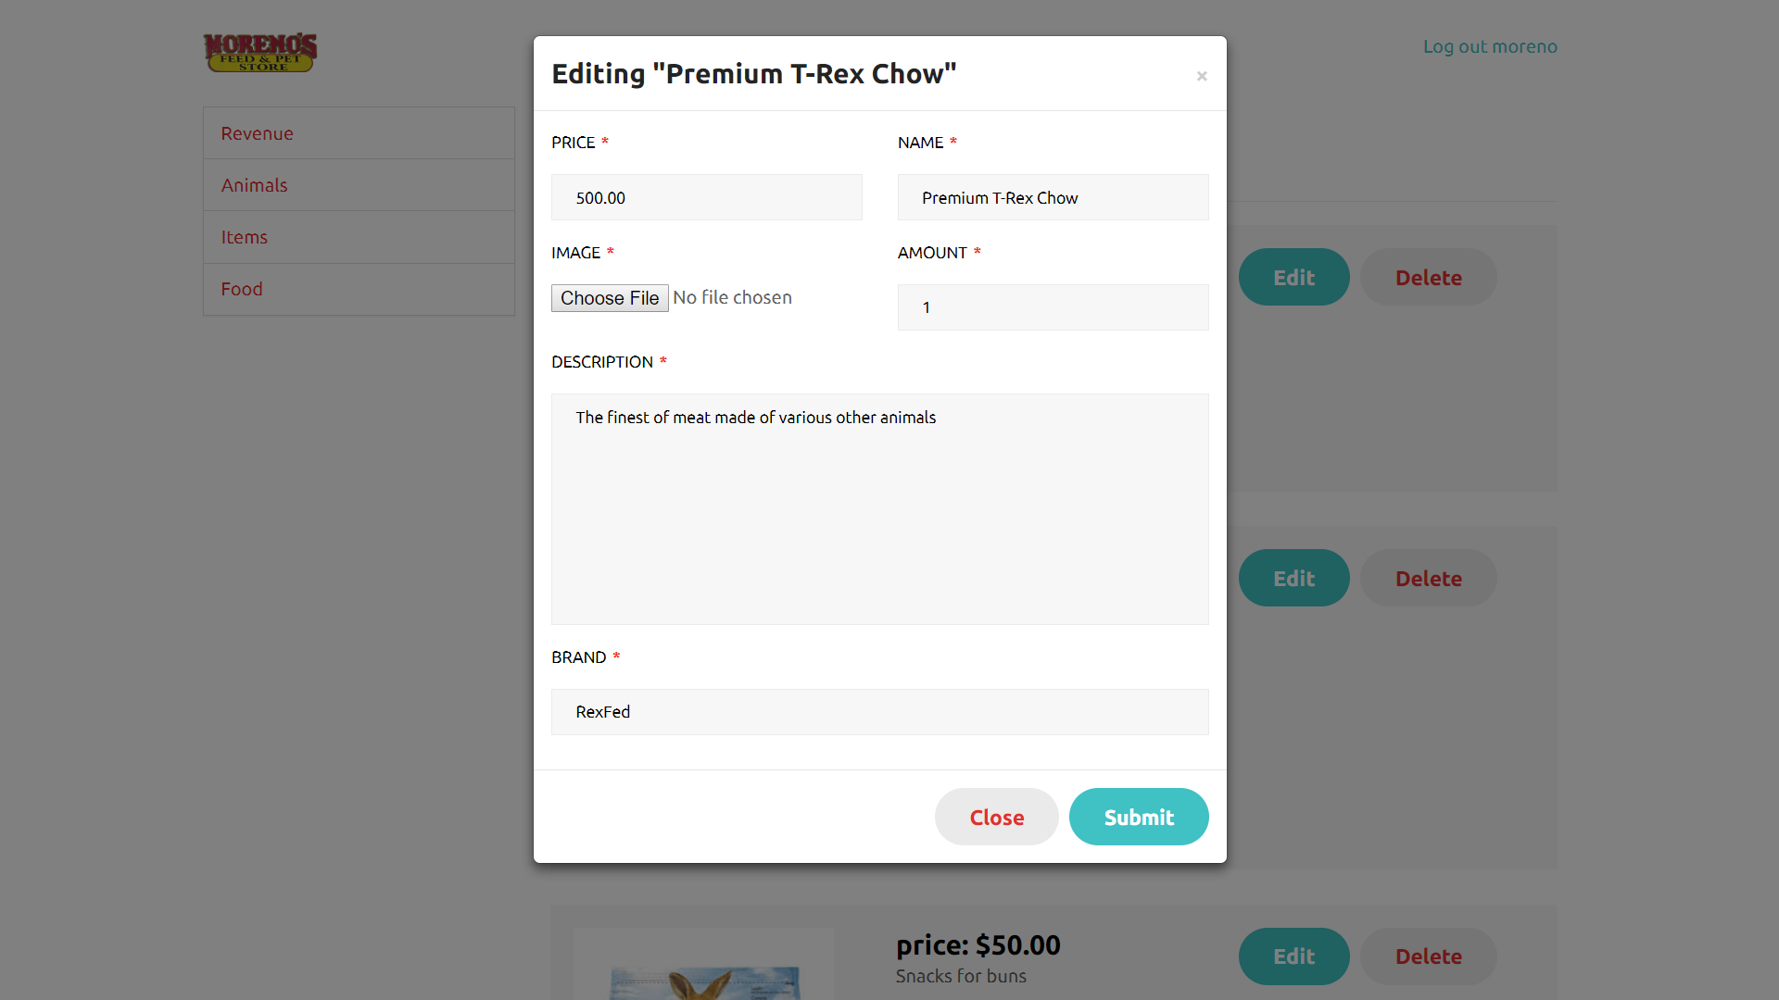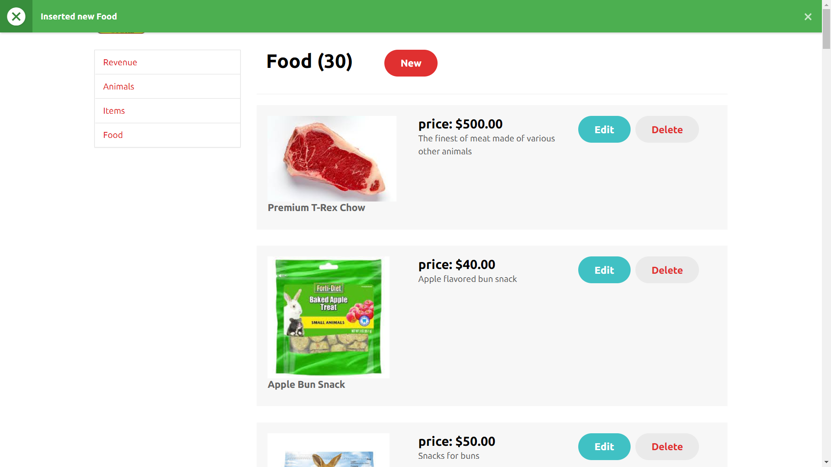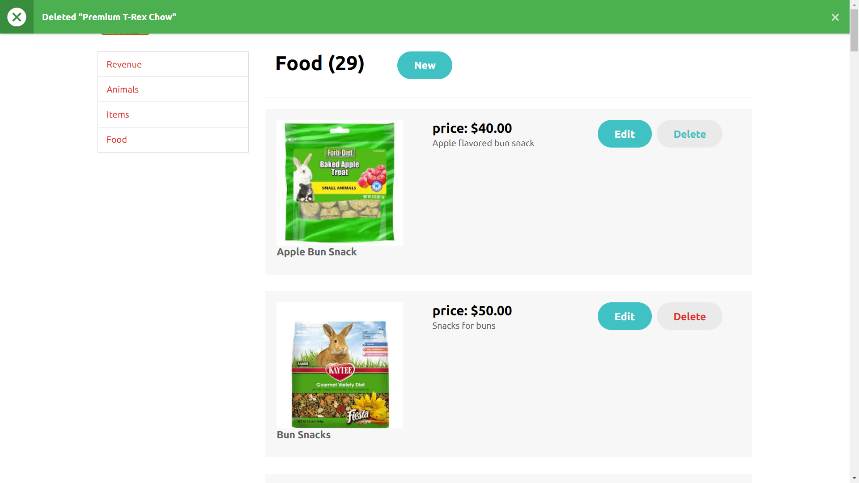

Code to insert product: | Code to update product: | Code to delete product:
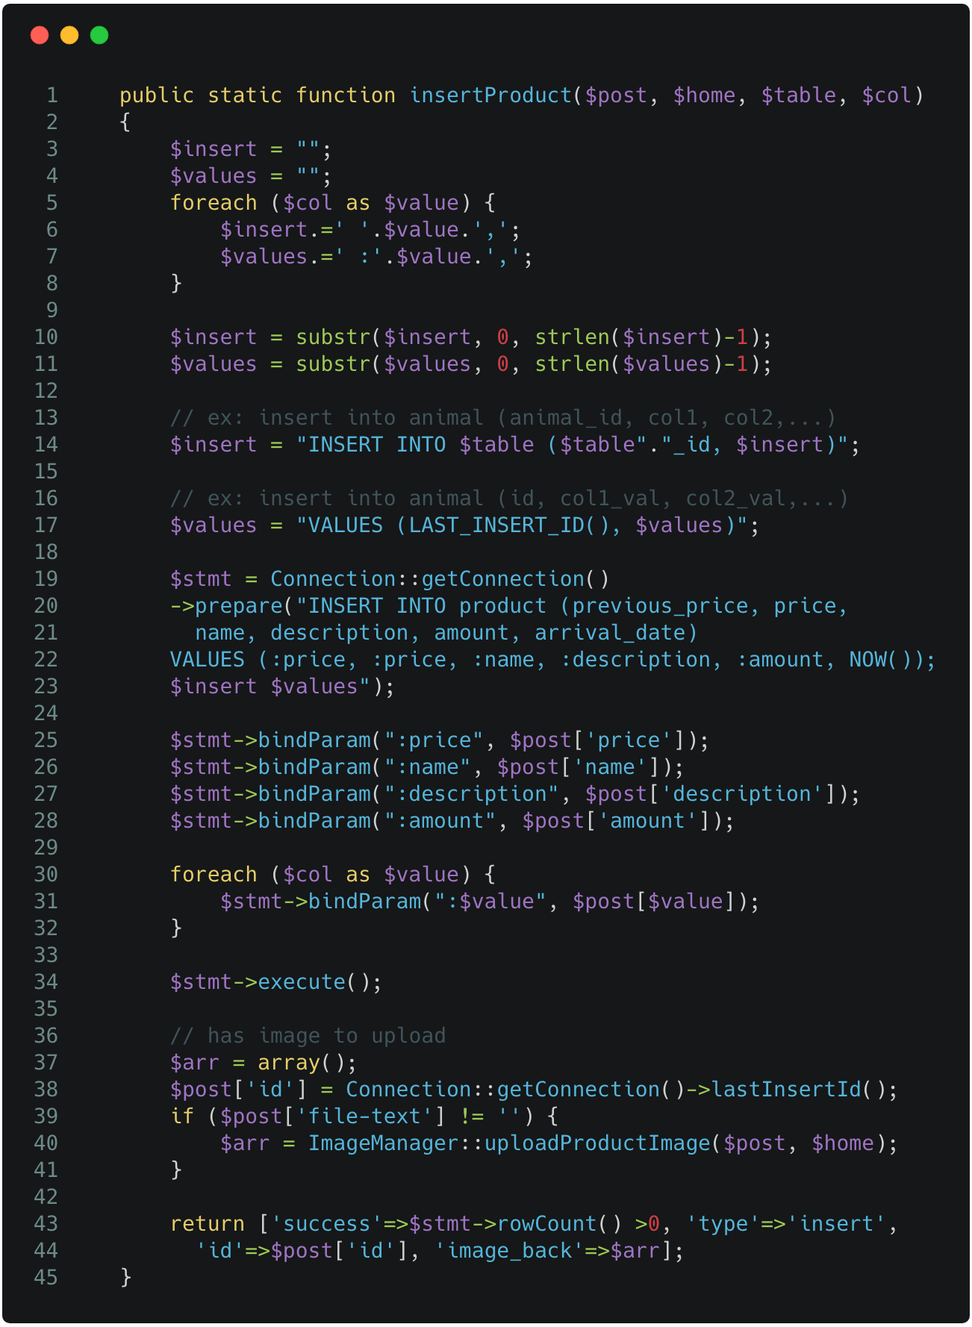 | 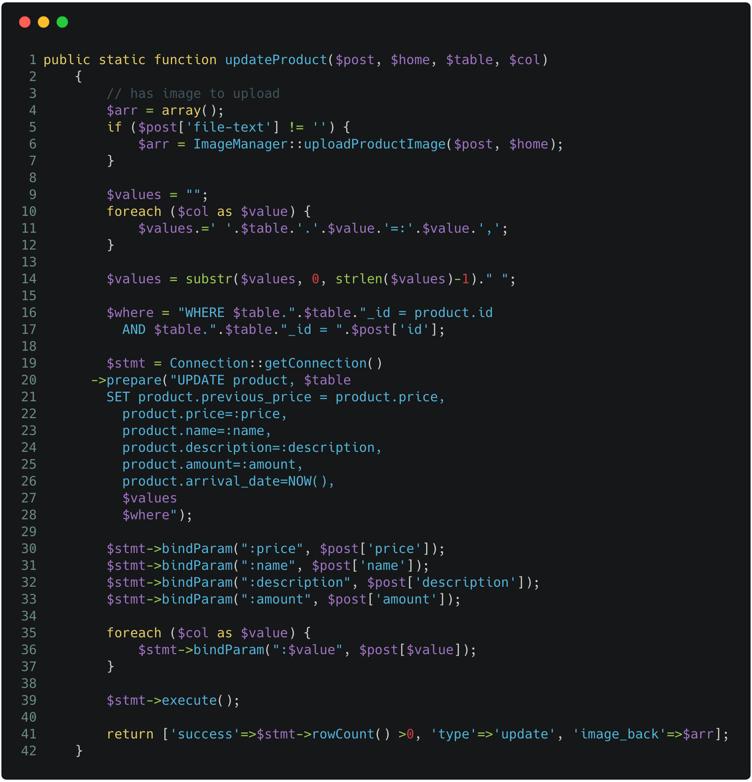 | 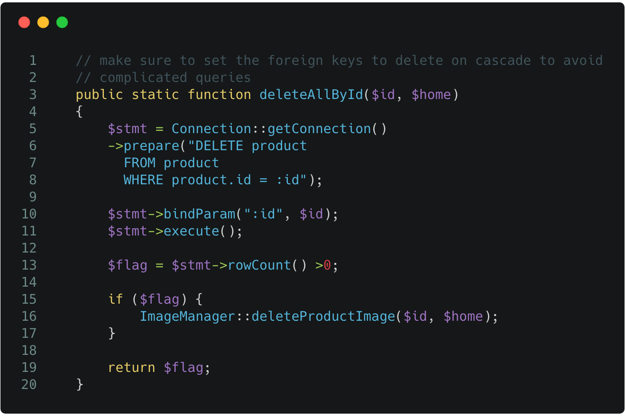

To conclude, the ADMIN has the power to create as many animals, foods, and items as they want, as well as edit or delete them.

- Usability
The usability of the website is extremely simple and easy to navigate, any user or guest to the website would be able to find their way throughout the website to find what it is they are looking for. The user should find the experience with the site to be quite enjoyable as they move from page to page with fluidity and without having to load too many pages in the process either. Ajax was used to call the backend which would then send back information in JSON format so that there would be no reloading of the page. Overall, the website should be easy to use for the average user.

- Testing
Over the course of the development of the database and website, there has been extensive testing on how each page of the website reacts with the database in tangent. Every page on the website queries the database for specific information that is relevant to the specific page. For example, when the user accesses the animal page, the database receives a query to display all currently available animals in the order that they were added, as a result the user will then see a page loaded with the various animals that are currently populating the database. The testing of each page was done thoroughly in order to ensure that all relevant information regarding a specific page was displayed correctly and was easy to navigate through.

- Contributions ToDO
Oscar Torres:
  - Database Developer/Designer
Took point on implementing the SQL and PHP that was required to communicate with the database from the initial site. Deployed the database and populated the database with the tables that later spawned the models for each respective part of the site. Lead the design of the new database and oversaw the overall progress of the database.

  - Front End Developer
Lead the development of the front end of the site, made many of the final decisions for the layout of any and all design changes. Programmed the basic functions of several of the pages, such as, the Product, Animal, Feed, and Item models. Took charge of the overall development and changes of the front end layout.

  - Back End Developer
Lead the development of the back end of the site, helped team members along in order to achieve the final result of a website with full functionality, not limited to sessions, a user cart for purchases, and PayPal functionality.
Lazaro Vallejo:
  - Front End Developer/Designer
Designed several different models and implemented the AJAX calls that helped facilitate communication with the database. Added the Slim implementation as well as the CSS styling to the web pages for cosmetic purposes.
  - Back End Designer
Did extensive work on several of the views to facilitate the transition between each page on the website. Worked on the User Model, Animal Model, Food Model, and the Product Model.

- Future Work
In the future the team would like to give the user the option to add several addresses, as well as designate which address would be used to ship their orders to. The team would also like to add a “seasonal” ordering service and an order history tab to keep track of previous orders. This could also lead to subscription-based orders that arrive in intervals set by the user.
- Conclusions
To conclude, the project was an overall success, the team worked tirelessly to meet the deadline and overcome many of the hurdles to accomplish the amount fully of functional components on the website. The new website for Moreno’s Pet and Feed Shop is live and ready to be visited by users and readily available for the administrator to use at petandfeed.com.
- References
http://php.net/manual/en/langref.php
https://dev.mysql.com/doc/en/
https://www.slimframework.com/docs/

Table of Contents

- Introduction
  - Problem Description
  - Background
  - Overview
- Database Design
  - TABLES
    - Admin Table
    - User Table
    - Revenue Table
    - Product Table
    - Animal Table
    - Item Table
    - Food Table
  - MODELS
    - Admin Model
    - User Model
    - Revenue Model
    - Address Model
    - Product Model
    - Animal Model
    - Item Model
    - Food Model
- System Design
- Routes
  - Admin Routes
  - User Routes
  - All Controller Routes
- Implementation
  - User Interactions
  - Admin Interactions
- Usability
- Testing
- Contributions
- Conclusions
- Future Work
- References

